 | United Nations | A/HRC/24/46
 | General Assembly |  | Distr.: General  16 August 2013  Original: English
Human Rights Council
Twenty-fourth session
Agenda item 4
Human rights situations that require the Council’s attention
Report of the independent international commission of inquiry on the Syrian Arab Republic*
Summary
The Syrian Arab Republic is a battlefield. Its cities and towns suffer relentless shelling and sieges. Massacres are perpetrated with impunity. An untold number of Syrians have disappeared. The present report covers investigations conducted from 15 May to 15 July 2013. Its findings are based on 258 interviews and other collected evidence.
Government and pro-government forces have continued to conduct widespread attacks on the civilian population, committing murder, torture, rape and enforced disappearance as crimes against humanity. They have laid siege to neighbourhoods and subjected them to indiscriminate shelling. Government forces have committed gross violations of human rights and the war crimes of torture, hostage-taking, murder, execution without due process, rape, attacking protected objects and pillage.
Anti-government armed groups have committed war crimes, including murder, execution without due process, torture, hostage-taking and attacking protected objects. They have besieged and indiscriminately shelled civilian neighbourhoods.
Anti-government and Kurdish armed groups have recruited and used child soldiers in hostilities.
The perpetrators of these violations and crimes, on all sides, act in defiance of international law. They do not fear accountability. Referral to justice is imperative.
There is no military solution to this conflict. Those who supply arms create but an illusion of victory. A political solution founded upon tenets of the Geneva communiqué is the only path to peace.
Contents
Paragraphs Page
I. Introduction 1–11 3
A. Challenges 5–6 3
B Methodology 7–11 3
II. Context 12–39 4
A. Political context 12–22 4
B. Military context 23–34 5
C. Socioeconomic and humanitarian context 35–39 7
III. Violations concerning the treatment of civilians and hors de combat fighters 40–110 7
A. Massacres and other unlawful killing 40–53 7
B. Arbitrary arrest and unlawful detention 54–62 9
C. Hostage-taking 63–66 10
D. Enforced disappearance 67–74 11
E Torture and ill-treatment 75–94 11
F. Sexual violence 95–100 13
G. Violations of children’s rights 101–110 14
IV. Violations concerning the conduct of hostilities 111–190 14
A. Unlawful attacks 111–135 14
B. Specifically protected persons and objects 136–159 18
C. Pillaging and destruction of property 160–169 20
D. Illegal weapons 170 21
E. Sieges and attacks on food security 171–190 21
V. Accountability 191–194 23
VI. Conclusions and recommendations 195–206 23
Annexes
I. Correspondence with the Government of the Syrian Arab Republic 26
II. Massacres 30
III. Inquiry into events in Al Qusayr 34
IV. Photographs of Al-Nayrab (Aleppo), May and July 2013 41
V. Map of the Syrian Arab Republic 42
I. Introduction
1. In the present report, the independent international commission of inquiry on the Syrian Arab Republic sets out its findings based on investigations conducted from 15 May to 15 July 2013.
2. In its resolution 22/24, the Human Rights Council extended the mandate originally established by the Council in its resolution S-17/1 for a period of one year.
3. The present report should be read in conjunction with the previous reports of the commission.
4. On 21 June 2013, the commission was invited to brief the Security Council on the situation in the Syrian Arab Republic. On 29 July, pursuant to General Assembly resolution 67/262, the Chairperson of the commission briefed the Assembly on the situation of human rights in the Syrian Arab Republic.
A. Challenges
5. The commission’s ability to reach victims from all sides and to present a full picture of the conflict was significantly curtailed by the denial of access to the Syrian Arab Republic. A thorough investigation requires access to the location of incidents, to all available information and to all available witnesses. Recent missions to the country by the Special Representative of the Secretary-General for Children in Armed Conflict and the United Nations investigation mission to investigate allegations of the use of chemical weapons give rise to hopes that the commission will be able to visit the country in the near future.
6. On 2 July, the commission addressed a request to the Permanent Mission of the Syrian Arab Republic in which it reiterated its request to have access to the country and sought information on the events in Al Qusayr in May and June (see annex I). On 16 July, the commission addressed a request to the Minister for Foreign Affairs that the members of the commission be granted access to the Syrian Arab Republic to examine the modalities for a future visit. No responses were received. On 5 August, a note verbale was sent to the Permanent Representative of the Syrian Arab Republic to the United Nations requesting information from the Government.
B. Methodology
7. The methodology employed for the present report was based on the standard practices of commissions of inquiry and human rights investigations, adapted to the above challenge. The commission relied primarily on first-hand accounts to corroborate its findings.
8. The information contained in the present report is based on 258 interviews conducted in the region and from Geneva, including via Skype and telephone. The total number of interviews conducted since the mandate began in September 2011 now stands at 2,091.
9. Photographs, video recordings, satellite imagery and forensic and medical records were collected and analysed. Reports from Governments and non-governmental sources, academic analyses and United Nations reports formed part of the investigation.
10. The standard of proof used in previous reports remains. This standard is met when incidents are corroborated to a level where the commission has reasonable grounds to believe that incidents occurred as described.
11. The commission investigated a number of incidents that may be labelled as “terrorist attacks” or “terrorism”. Once the threshold of non-international armed conflict has been met, and the suspected perpetrators are parties to the conflict, the commission renders its assessment of an attack’s legality under the rubric of international humanitarian law and international human rights law. Any attack the sole purpose of which is to spread terror among the civilian population is prohibited.
II. Context
A. Political context
12. The situation in the Syrian Arab Republic was discussed in a June meeting of the Friends of Syria group in Doha and at the margins of the Group of Eight summit on 17 and 18 June in Northern Ireland, with little apparent progress towards a solution to the conflict. As prospects for a political settlement stagnate, the warring parties’ willingness to negotiate has been affected by military developments on the ground.
13. Despite the efforts of the Joint Special Representative of the United Nations and the League of Arab States for Syria, agreement on a date for the proposed conference in Geneva remains elusive. The Government and the Kurdish Syrian forces have agreed, in principle, to send separate delegations to the conference. After making its participation conditional on a shift in military momentum, the Syrian National Coalition now appears to have agreed, in principle, to attend the conference.
14. Both the Government and anti-government armed groups believe that they can achieve a military victory. Their respective supporters afford them political coverage, financial assistance and military hardware, turning the Syrian conflict into a proxy war of regional and international interests.
1. The parties
15. The Government continues to struggle to provide security and basic services in areas under its control where living conditions have further deteriorated.
16. The Syrian opposition remains marred by internal strife. On 6 July 2013, the Syrian National Coalition voted in a new President, Ahmad Asi Al-Jarba, almost three months after the resignation of Moaz Al-Khateeb. Two days later, Prime Minister Ghassan Hitto resigned, citing the inability to form an interim Government to be entrusted with the administration of areas under opposition control. On the ground, the political vacuum has fed the ongoing fragmentation and disintegration of political authority, as signalled by recent infighting in Latakia governorate between some anti-government armed groups.
17. In the north-east, friction over power-sharing emerged within the Kurdish political leadership, formally united under the Kurdish Supreme Council. Despite tensions, recent statements made by representatives of the Kurdish parties indicate that parliamentary elections are being prepared in the areas under Kurdish control. Elections will be preceded by a referendum on an interim constitution currently being drafted.
2. Regional dimension
18. The joint call made by Turkey and the Islamic Republic of Iran for a truce to come into force during Ramadan, which reiterated an appeal by the Secretary-General, was disregarded by all parties.
19. Regional allies continued to provide military and financial support to the Government. Hizbullah now fights alongside government forces; young Iraqi Shiites are travelling to the Syrian Arab Republic to fight for the Government. The Government’s currency crisis has been temporarily stemmed by the extension of a $3.6 billion credit line from the Islamic Republic of Iran. A loan from the Russian Federation is reportedly under discussion, while pre-conflict arms deals between Moscow and Damascus continue to be honoured.
20. Influential Sunni clerics from several Arab States, including Saudi Arabia and Egypt, called on Sunnis to join the jihad against the Government of the Syrian Arab Republic and its supporters. Appeals, echoing an earlier call made by Al-Qaida leader Zawahiri, urged that money and weapons be provided to anti-government armed groups.
21. The conflict continues to affect the internal political dynamics of neighbouring countries. Nowhere is this more evident than in Lebanon: fierce clashes in Tripoli and Sidon; kidnappings, roadside bombs and cross-border shelling in the Beqaa Valley; rockets and a car bomb in Beirut, where a protester was killed during a sit-in in front of the Embassy of the Islamic Republic of Iran, were just a few instances of spreading violence. Lebanon hosts the largest number of Syrian refugees: according to the United Nations High Commission for Refugees, there were 665,978 as at 1 August. Jordan hosts more than 500,000 refugees, a quarter concentrated in Zaatari camp on the northern border with the Syrian Arab Republic, provoking growing concerns about the impact on the Kingdom’s economy, security and stability.
22. On 5 July, Israel attacked a site near Latakia, apparently targeting Russian-made missiles. This, and previous attacks inside the Syrian Arab Republic, could lead to a reassessment of the conflict in the legal framework of an international armed conflict.
B. Military context
23. The conflict is deadlocked, with both warring parties convinced that a military victory is possible. This has led to an intensification of hostilities along distinct, though fluid, battle lines. Fighting continued, with both sides consolidating forces in their primary strongholds. Government forces continued to control major cities and lines of communications, while anti-government armed groups reinforced their presence in large swathes of the northern and eastern governorates, and areas along the Jordanian border. More regional actors were sponsoring flows of fighters and equipment, increasingly along sectarian lines, leading to a rise in corresponding violence. Meanwhile, the conflict has expanded beyond the country’s borders, re-igniting tensions in fragile neighbouring countries and threatening regional peace and security.
1. Government and pro-government forces
24. Government forces have seized the momentum in the past three months, recapturing some of the areas lost previously to the armed groups and consolidating their control over contested regions, particularly in Homs and Damascus countryside.
25. With the exception of Aleppo city, government forces reinforced their hold over major cities and economically important areas. Despite the efforts of armed groups, government forces successfully held most strategic military positions, air force bases and main lines of communication in Aleppo and Idlib. They disrupted supply lines linking armed groups to their networks across the borders.
26. Government forces continued to rely on heavy and often indiscriminate firepower to target areas they were unwilling or unable to recapture through ground operations. A variety of fire assets, including missiles, jet fighters and artillery, were systematically employed against restive localities to prevent a return to normality under armed group control and to sanction the local population.
27. Battle-hardened and growing accustomed to fighting an insurgency, government forces benefited from wide logistical support and personnel provided by allies, including the deployment of military advisers. The army was invigorated by the increased support of the National Defence Forces and by the involvement of foreign irregular forces, in particular Hizbullah. These regenerated combat power, replacing losses through deaths, defections and the increasingly difficult recruitment of new troops.
28. Defections continued to spare the core of military and security forces and steadily declined, even among the less-trusted units.
2. Anti-government armed groups
29. Anti-government armed groups reinforced their control over large swathes of the northern and eastern governorates, but failed to hold key positions in Homs and Damascus. Persistent divisions and lack of logistical support seriously limited their operational capacity to face the latest offensives of government forces.
30. A number of diverse and initially profoundly divided insurgent groups have evolved into a more organized force. Alliances operated across several fronts, with increasing collaboration among groups. They failed, however, to unify their structures under a coherent command owing to their divergent objectives and resources. The efforts of the Supreme Joint Military Command Council were undermined by its inability to centralize logistical support and to integrate existing command networks. More recently, discord grew among groups with different loyalties, occasionally leading to confrontation over areas and resources.
31. The fluctuating and erratic support provided by a number of countries and wealthy individuals to the armed groups was sufficient to escalate hostilities, but is unlikely to fundamentally determine the course of the conflict. Support mainly benefited the armed groups operating along the borders. Those positioned in central areas recently lost control of their supply lines.
32. Anti-government armed groups were equipped mainly with small arms and light weapons, although they occasionally increased their use of anti-tank and anti-aircraft systems. They also employed mortars and artillery guns to target military and security positions, including those within residential areas.
33. Despite efforts to limit the extremists’ influence in opposition circles, the radicalization of anti-government fighters continued. Alongside a growing number of foreign fighters, the discipline and operational abilities of radical fighters, combined with better access to reliable sponsors, allowed them to outmatch the fractious moderate groups. The most radical, such as Jabhat Al-Nusra and the Islamic State of Iraq and Al-Sham (ISIS), developed their own strongholds in the north. ISIS subsumed the Islamic State of Iraq, a group which, with Al-Nusra, is on the sanctions list maintained by the Security Council Committee pursuant to resolution 1267 (1999).
3. Kurdish armed groups
34. Armed violence flared in Kurdish areas in the north-east, where the role of local militias in the conflict grew. Prioritizing their neutrality and the protection of Kurdish localities, the People’s Protection Units (YPG) clashed with both government forces and anti-government armed groups. There was a spike in tensions with radical anti-government armed groups. Intra-Kurdish disputes also arose.
C. Socioeconomic and humanitarian context
35. Since January 2013, the number of refugees has grown from approximately 600,000 to more than 1.85 million.
36. The influx fuelled tensions between refugees and their host communities. In refugee camps, women and girls are vulnerable to sexual exploitation, forced marriage and trafficking. There are increasing incidents of domestic violence. Hardships compelled some refugees to return to the Syrian Arab Republic.
37. Oil exports decreased, partly owing to sanctions. Some oil fields are now controlled by opposition forces, including those affiliated with Al-Qaida, which benefit from sales. The manufacturing sector contracted owing to both the destruction of factories and sanctions. The burning of crops and the disruption of agriculture raised prices of goods, including flour.
38. Notwithstanding the ever-growing number of people in need of urgent assistance, the Government and some anti-government armed groups obstructed the delivery of humanitarian assistance. Despite security constraints, some cross-line deliveries of aid were made, but were insufficient to meet the ever-growing needs of the affected population. Some locations remained inaccessible. Some 2.8 million people are in need inside the country. The situation is particularly dire in besieged areas of Aleppo, Homs and Damascus.
39. United Nations aid agencies have estimated that $3.1 billion is needed to aid the affected population, in the Syrian Arab Republic and in neighbouring countries, until the end of 2013. Only half the pledges made at the international donors’ conference held in Kuwait in January 2013 have been fulfilled.
III. Violations concerning the treatment of civilians and hors de combat fighters
A. Massacres and other unlawful killing
40. Individuals were regularly killed in contravention of international law, which criminalizes both murder and execution without due process. International human rights law prohibits arbitrary deprivation of life. Common article 3 of the Geneva Conventions prohibits execution without previous judgement pronounced by regularly constituted courts affording judicial guarantees.
1. Government and pro-government forces
41. Deaths in custody rose markedly. Deaths from torture were recorded in centres controlled by the Air Force, Political and General Intelligence and Military Security. Many cases were recorded in General Intelligence Branch 295, 20 km east of Damascus, and Branch 251, in Damascus. One former detainee held in the Al-Fehar Branch of Political Security in Al-Mezzeh (Damascus) barely survived. He detailed the deaths of others. Detainees were tortured to death in Military Security Branch 215 (Damascus).
42. Other unlawful killings included checkpoint shootings (Damascus, June), snipers killing civilians (Damascus countryside, June) and unlawful killing of civilians during ground operations (Homs, February, March, April and June; Hamah, February; Damascus countryside, June).
43. A “terrorism court” was established in Al-Mezzeh to hear cases that violate the 2012 Anti-Terrorism Law. Accused were not informed of the allegation, nor were they afforded timely access to counsel. The Government also established military field courts. No legal representation, family visits or appeals were allowed, yet judges may confer capital sentences.
44. Unlawful killing was perpetrated by government forces as part of widespread attacks directed against the civilian population. The attacks included widespread shelling of villages, the burning of civilian objects, sniper attacks and systematic executions (see annex II). The coordination and active participation of Government institutions indicated the attacks were institutionalized and conducted as a matter of policy. Unlawful killing occurring during such attacks were crimes against humanity. Government forces also committed the war crime of murder, carried out executions without affording due process and arbitrarily deprived the right to life.
2. Anti-government armed groups
45. On 8 June, ISIS fighters executed a 15-year-old boy, Mohamed Qatta, accused of blasphemy.
46. In June, an anti-government armed group killed a Catholic priest, Father François Murad, in Idlib. The priest was one of the only remaining Christians in the town of Ghassaniya. Jabhat Al-Nusra was active in Ghassaniya at the time.
47. Quasi-judicial mechanisms established by anti-government armed groups varied considerably across areas under their control. The lack of codified law led to an inconsistent administration of justice. Essential judicial and procedural guarantees were rarely accorded, and most judicial mechanisms did not reach the necessary level of independence and impartiality.
48. The punitive mechanisms established by some armed groups deny the right to counsel and the opportunity for appeal, given that executions were carried out immediately after sentencing. The close functional relationship between armed groups and courts compromised the independence and impartiality of the latter.
49. In Hamah, persons arrested or captured by armed brigades are transferred to one of two parallel quasi-judicial mechanisms, following military interrogation. The local security committee has jurisdiction over disputes between armed groups and minor criminal and civil offences. Serious cases, such as murder, are referred to the sharia committee in Bab Al-Hawa, Idlib. Those found guilty can be executed. A captured soldier or pro-government fighter who “confesses” faces immediate execution, without referral to the sharia committee. On 20 May, a captured soldier was executed in Qalat Al-Madiq after confessing to killing a fighter for the Free Syrian Army (FSA).
50. Military councils in Dara’a set up sharia courts to investigate allegations, operate detention facilities and conduct trials. In practice, court judges operate under the authority and instruction of the councils. Captured government soldiers or those that defected in Dara’a are reportedly not executed, but may be imprisoned for such crimes as spying. Those accused are not permitted defence counsel.
51. In Dayr az Zawr, armed groups accepted the jurisdiction of a local court. Judicial authority was exercised by legal scholars, religious scholars and legal professionals that had defected from the Government and applied a hybrid of Islamic and Syrian civil law.
52. The war crime of murder and the crime of executing without due process were perpetrated by anti-government armed groups.
3. Kurdish armed groups
53. In June, in the town of Amudah (Al Hasakah), several protestors were shot and killed by YPG forces. A 12-year-old girl and a 15-year-old boy were among the deceased. Rocks and bottles had been thrown at YPG fighters, and they claimed that one of their ranks had been shot. The YPG committed an abuse of human rights associated with the disproportionate use of force.
B. Arbitrary arrest and unlawful detention
54. Thousands of people have been apprehended since the conflict began. Most face a string of interwoven human rights violations, often culminating in their torture or death. Some bribe their way out; a relatively small number were “amnestied”. Others eventually appeared before a judge and were sentenced. Most languished in overcrowded cells with no access to judicial oversight, legal counsel or their families.
1. Government and pro-government forces
55. Since 2011, government forces have conducted arbitrary arrests on an enormous scale. Males over the age of 15 years were routinely arrested during raids. Arrests are increasingly made by entities with no or dubious arresting authority, such as the National Defence Forces. In June, Hizbullah arrested Syrians in Dayr Atiyah. Detainees were typically held for days outside the law and subjected to severe maltreatment before being transferred to security services.
56. A presidential decree promulgated in March required all 18-year-olds to report for military duty, or face arrest. Boys appearing to be 18 were detained at checkpoints. At Al-Madakah checkpoint (Dara’a), soldiers routinely arrested and ill-treated young men on the pretext that they had not enlisted.
57. Internally displaced persons are especially vulnerable to arbitrary arrest as they fled conflict-affected areas, often without documents. Arrests appeared to be predicated on the person’s originating from a restive area or being a family member of wanted persons, such as defectors. Cases of internally displaced persons arrested at checkpoints were recorded in Al-Nabak (Damascus countryside), Al-Madakah (Dara’a), Qusayr, Al-Houlah (Homs), Al-Bayda (Tartus) and Masharah (Al-Qunaytirah). In May and June, in Job Al-Jarrah (Homs), National Defence Forces raided the area, arresting displaced Sunnis in what was viewed as an attempt to evict them.
58. In some cases, family members were arrested if the person wanted could not be found. In one case, a girl, released from detention in April in Damascus, was arrested to gain information on her brother’s activities. In Karnaz (Hamah) in March, soldiers detained the wife and children of a wanted man.
59. Medical staff were arrested on the pretext of “having supported terrorists” when they provided medicine or medical aid to fighters. Many Red Crescent volunteers were detained for “assisting terrorists”.
60. The arrest or detention of persons on discriminatory grounds violated the State’s human rights obligations. Medical staff are protected under international law irrespective of the party to which their patients belong. Depriving detainees of such fundamental rights as the presumption of innocence, being informed of the charges against them to having their detention reviewed by an independent authority violates international human rights law and international humanitarian law.
2. Anti-government armed groups
61. The number of people detained by anti-government armed groups is rising, as are instances of arbitrary arrest and illegal detention. In April, a doctor in Aleppo was detained for refusing to allow Jabhat Al-Nusra to hoist its flag over a field hospital. More than 150 people were detained in the same location, and none had access to counsel. Family visits were also prohibited. In Ar Raqqah, ISIS is holding several hundred prisoners, including community activists and women. The legal basis for anti-government groups detaining individuals is unclear. There is no indication that detainees are being granted their fundamental rights.
3. Kurdish armed groups
62. In areas under Kurdish control, arbitrary arrest is also on the rise. In March, a woman protesting in Afrin against YPG was arrested. In May, YPG forces detained opposition activists. YPG was involved in “tit-for-tat” abductions with other opposition groups. While an ad hoc judicial mechanism exists, its efforts to exercise authority over detainees appear limited.
C. Hostage-taking
63. Hostage-taking and kidnapping have risen sharply. Armed men, motivated by financial gain or to exchange prisoners held by opposing forces, abduct and hold individuals under threat of death. Scores remain captive; others have been released after negotiation. In the period under review, dozens were killed.
1. Government and pro-government forces
64. Pro-government militia were involved in kidnappings in volatile areas across the Syrian Arab Republic. Multiple cases of kidnappings occurred among groups inside, and those laying siege to, Nubl (Aleppo). One interviewee described these abductions as “quite common”. In February, in Al-Hajar Al-Aswad (Damascus), two older men in a car were seized while passing through a checkpoint manned by National Defence Forces. Their families were later approached and ransom was sought for their release.
2. Anti-government armed groups
65. Kidnapping and hostage-taking by armed groups also revolved around ransoms and prisoner exchange. On 25 March, following the arrest of a fighter’s wife and children by pro-government forces (see paragraphs 54 to 62), a group of fighters abducted three women from Al-Suqaylabiyah (Hamah). The kidnappers contacted a religious leader, and informed him of the abduction and the conditions for release. Abductees from both sides were allowed a phone call to their families. An exchange was negotiated and all women were released unharmed.
66. Both pro-government forces and anti-government armed groups engaged in hostage-taking, in violation of international humanitarian and criminal law.
D. Enforced disappearance
1. Government and pro-government forces
67. Instances of enforced disappearance have risen exponentially since the conflict began. By placing victims outside the protection of the law, government forces sewed terror among the civilian population.
68. Enforced disappearance infringes on a person’s fundamental human rights, including the rights to liberty, to personal security and to a fair trial. A crime under international law, it is a violation which persists for years after the initial arrest or abduction. It is a gateway to other offences, such as torture.
69. Enforced disappearance was carried out by government forces, including Air Force and Military Intelligence, and by National Defence Forces. In Aleppo, Damascus, Dara’a, Dayr az Zawr, Hamah and Homs, civilians were arrested following army raids. Individuals were abducted in their homes, at checkpoints, in mosques and in hospitals. Victims were taken to unknown locations, their whereabouts undisclosed.
70. Across the country, families wait – sometimes for extended periods – to know the fate and whereabouts of their relatives. One interviewee’s brother was arrested in Dara’a in March 2012 by members of Security Branch 215, and has not yet reappeared.
71. Families have justified fears that searching for their relatives may lead to reprisals. Some who reported a disappearance were themselves detained. Authorities also refused to provide information or to acknowledge arrests. One defector, who worked in Air Force Intelligence in a central governorate until late 2012, cited orders that information about detainees was not to be provided to their relatives. The desperation of families has left them vulnerable to extortion. Some families pay bribes to those who – often falsely – claimed they could provide information.
72. In most cases, the only way to obtain information is when a detainee is released. One interviewee, held for over a year by an intelligence agency, was confronted upon his release by dozens of women thrusting photographs of their male relatives towards him, hoping he might have seen them during his detention.
73. Most frequently targeted are males over the age of 15. In some cases, however, elderly women and children have been “disappeared”. One interviewee reported that, following the army’s counter-offensive in Bab Amr in March, soldiers abducted his neighbours, including women and children. These families were not seen again. Medical personnel, internally displaced persons and individuals fleeing the violence have also vanished. On 8 June, a family fleeing fighting in Al-Waar neighbourhood, Homs city, was stopped by soldiers. The husband was arrested and taken to an unknown location.
74. Enforced disappearance is used by government and pro-government forces as a strategy of war, to stifle dissent and to spread terror within society. It is committed as part of a widespread attack against a civilian population, with knowledge of the attack, and constitutes a crime against humanity.
E. Torture and ill-treatment
75. Torture remains widespread. Severe physical and mental pain and suffering is deliberately inflicted to obtain information or confessions, as punishment, to intimidate or coerce. The prohibition of torture under international human rights law and humanitarian law is absolute, triggering both State and individual responsibility.
1. Government and pro-government forces
76. The Government, including its intelligence agencies, employed widespread, systematic torture to interrogate, intimidate and punish its perceived opponents. Torture was used in detention centres, security branches, prisons and hospitals.
77. Previously reported torture methods remained in use across the country. Many of the victims interviewed carried visible scars consistent with their accounts and exhibited symptoms of psychological trauma.
78. Interviewees consistently identified Air Force Intelligence (AFI) as one of the worst perpetrators. In Hamah, AFI detainees were beaten upon arrest and tortured during interrogations. According to an AFI defector in Hamah, personnel who used torture faced no disciplinary measures.
79. Military Security interrogated those apprehended by the army and routinely used torture. One detainee, arrested in Dara’a city in mid-May, was released from Military Security three weeks later with a broken leg and multiple cigarette burns on his back. Another former detainee described being tortured in Military Security Branch 235.
80. Victims in these centres were subjected to previously undocumented torture methods. Military Intelligence officers used water torture, such as simulated drowning, at Branch 227. Detainees in the Al-Fehar Branch in Damascus were held in solitary confinement “squatting cells”, in which it was impossible to stand upright or lie down. One detainee was held in such conditions for 10 months, beaten daily, suspended by his wrists for 17 days, burned with cigarettes and subjected to electric shocks.
81. Where detainees were brought before Government courts in Aleppo city, they bore evident marks of torture, which were ignored by the judiciary.
82. Medical professionals at some military hospitals were co-opted into the maltreatment of hospitalized detainees.
83. Security and intelligence services operated detention centres within Abdul Gadir Al-Shagafi Military Hospital in Al-Waar, Homs, and at Al-Mezzeh Military Hospital in Damascus. Detainees were brought in bound and blindfolded. They were registered according to the number of the detaining authority. Security personnel guarded the detainees and acted as intermediaries between patient and doctor.
84. Cases were recorded of patients being tortured in these hospitals in coordination with various security branches. Patients were reportedly beaten in the guarded 14-bed ward of Al-Mezzeh Military Hospital.
85. The bodies of those tortured to death in Abdul Gadir Al-Shagafi Military Hospital and in State Security in Damascus were transferred to hospital morgues. Most bodies were not returned to their families. Some were returned to their family in exchange for a signed statement confirming that the victim had been killed by “terrorists”.
86. Multiple reports were received of beatings and ill-treatment at checkpoints and other points of arrest. Most victims were men accused of assisting the opposition, and they were often transferred to Military Security and tortured during interrogations. A man was arrested in January at a checkpoint in Khalidiyeh (Homs). He was detained until his death in June. His body was covered with injuries consistent with extensive beating and whipping.
87. Beatings were documented at the checkpoint at the entry of Dara’a, operated by Military Security, the checkpoint in Deir Baalbah operated by Political Security and at checkpoints along the Homs-Damascus highway, which contained short-term detention facilities where detainees were beaten prior to their transfer to the Military Intelligence, outside Masharah (Al-Qunaytirah) and in Al-Ashrafiyah (Aleppo).
88. Torture and other forms of cruel, inhuman or degrading treatment or punishment were perpetrated by government forces as part of a widespread and systematic attack directed against a civilian population, pursuant to or in furtherance of an organizational policy. The involvement and active participation of government institutions indicated that torture was institutionalized and employed as a matter of policy. The crime against humanity of torture and cruel treatment was perpetrated with impunity by Syrian intelligence agencies, in particular Military and Air Force Intelligence, as well as the Military Security services. Such conduct is also prosecutable as a war crime.
2. Anti-government armed groups
89. Some anti-government armed groups mistreated and tortured persons in their custody. While such violations were committed in isolated instances, there are strong indications that such practices are on the rise.
90. In mid-May, members of a sharia committee in northern Aleppo city arrested and detained several activists following a peaceful demonstration, and subjected them to physical violence, including beating them on the soles of their feet.
91. Liwa Asifat Al-Shamal operated a 300-person capacity prison in Azaz (Aleppo) where, as a method of interrogation, detainees were put in a 1.5 m deep hole in the ground and covered with sheet metal for 48 hours.
92. On 19 July, the Saddam Hussein Battalion, part of the Liwa Al-Tawheed military police, beat and tortured a man using the dulab method.
93. Some ant-government armed groups perpetrated the war crime of torture. The infliction of cruel, inhuman or degrading treatment or punishment is also a violation of international human rights law and humanitarian law.
3. Kurdish armed groups
94. In February, YPG forces in Afrin beat anti-government protesters and detained persons affiliated with the FSA. Accounts were received of the setting up of makeshift prisons near Afrin, where detainees were beaten. The YPG has inflicted cruel, inhuman or degrading treatment or punishment, a violation of international human rights law and humanitarian law.
F. Sexual violence
95. Sexual violence has played a prominent role in the conflict, owing to the fear and threat of rape and by the violence committed. It occurs during raids, at checkpoints and in detention centres and prisons across the country. The threat of rape is used as a tool to terrorize and punish women, men and children perceived as being associated with the opposition. Underreporting and delayed reported of sexual violence is endemic, making an assessment of its magnitude difficult.
1. Government and pro-government forces
96. Sexual violence was committed against women during raids by pro-government forces in Dara’a, Hamah and Tartus. A woman was raped by a security officer during a raid in Dara’a in December 2012. A National Defence Force fighter attempted to rape a woman in her home in Tartus during a raid in May.
97. Detention centres and prisons were the locations most often cited for sexual violence. In late April, a woman released from the Political Intelligence branch in Damascus described how she had been forced to orally copulate with her interrogators. A woman detained at Al-Mezzeh in Damascus in December 2012 described the rape of cellmates. In late January, FSA fighters captured a detention centre in Dayr az Zawr and found a family among the prisoners. Under threat that her children would be killed, the mother was raped and forced to clean and cook for her captors.
98. The threat of rape was used as a tool to coerce confessions. Two women, held at Al-Mezzeh and Branch 235 in Damascus respectively, were told by their interrogators that their daughters would be raped if they did not confess. A nurse held at a police station in Damascus was threatened with gang rape if she failed to reveal whom she was treating.
99. Women were harassed, insulted and, in some instances, beaten at checkpoints in Damascus, Dara’a, Homs and Al-Qunaytirah. A university student was raped at a checkpoint in Dara’a in early 2013 because her brother was wanted by the Government. Afterwards, the FSA arranged for her to marry someone in order to “protect her honour”.
100. Rape and other inhumane acts, as crimes against humanity, were committed by government forces and the National Defence Forces. Rape and inhuman treatment are also prosecutable as war crimes.
G. Violation of children’s rights
1. Government and pro-government forces
101. Most child deaths and injuries were caused by shelling and aerial bombardments. On 4 June, a missile strike on Kafr Hamrah (Aleppo) killed 63 people, including 10 young children. There were no military targets nearby. On 12 June, during the shelling of Tell Al-Shaykh (Dara’a), a 13-year-old girl was severely wounded when a shell struck her house. Her mother died and her two sisters were seriously injured in the attack.
102. Children were the victims of executions. When pro-government forces raided Al-Bayda (Tartus) on 2 May, boys aged around 13 to 15 years were killed alongside adult men. On 10 April, in Khirbet Al-Teen (Homs), a Bedouin family was killed. The adults were shot, while the four children had their throat cut (see also annex II).
103. Young men join – sometimes voluntarily, sometimes forcibly – the army and the National Defence Forces. Three 17-year-old boys were forcibly recruited at checkpoints in Aleppo; one was killed within two weeks. Young recruits were reportedly mistreated and pushed towards frontlines by older soldiers. Sixteen- and 17-year-olds have been observed in the National Defence Forces.
104. In June, 10 boys aged 14 to 17 years, who were with a group of around 50 civilians displaced from Homs, were taken from a bus, forced to strip naked and were beaten at a checkpoint run by Political Security in Deir Baalbah (Homs). They were later released.
105. Adult detainees regularly reported the detention and torture of children as young as 13 in detention facilities.
2. Anti-government armed groups
106. Children were killed when armed groups indiscriminately shell civilian areas. On 15 June, a 10-year-old boy in Al-Fou’a (Idlib) was killed by indiscriminate shelling from positions in neighbouring Binnish.
107. On 8 June, three armed men executed 15-year-old Mohamed Qatta in Aleppo. Two children were among 27 people killed in Hatla (Dayr az Zawr) on 10 June (see annex II).
108. Some armed groups recruited children under the age of 18. The ranks of both Liwa Al-Tawheed and Jabhat Al-Nusra included fighters between the ages of 14 and 18. Younger fighters were not armed with heavy weaponry, but underwent a training programme and participated in hostilities on the front. One fighter explained that children were recruited because “they fight with enthusiasm; they are fearless”.
109. A 13-year-old boy enlisted with an FSA brigade in Dara’a after his school ceased to operate. He was not allowed to carry weapons or ammunition but used as a porter, whose duties included carrying the wounded and medicines, and preparing ammunition. He was seriously wounded in May. Another boy, who provided support services to an FSA-affiliated group, joined when he was 13 years old after seeing his father humiliated at a checkpoint.
3. Kurdish armed groups
110. In Afrin (Aleppo) and Al Hasakah, the YPG recruited boys and girls from the age of 12. In late 2012, large numbers were recruited to counter an attempt by Jabhat Al-Nusra to enter Al Hasakah from Turkey.
IV. Violations concerning the conduct of hostilities
A. Unlawful attacks
111. Most civilian deaths result from indiscriminate or disproportionate shelling. These unlawful attacks are a primary reason for the movement of people inside the Syrian Arab Republic and over its borders.
112. Unlawful attacks by government forces were documented in almost every governorate. In particular, towns and villages hosting internally displaced persons from restive areas, such as Homs, were relentlessly assaulted.
113. Some anti-government armed groups – notably in northern Aleppo and in Idlib countryside – also shelled indiscriminately.
1. Government and pro-government forces
114. Across the country, the Government shelled civilian areas with artillery, mortars and rockets. Aerial bombardment by helicopters and jet fighters was common and, in some areas, a daily occurrence. Imprecise weaponry, such as surface-to-surface missiles and cluster munitions, was regularly used. Defectors indicated that there was a retributive element to some attacks, to “punish” civilians for the presence of armed groups.
115. Government forces continued to fiercely shell and bombard contested areas of strategic importance (see annex III for a description of the attack on Al Qusayr and the surrounding villages by government forces and Hizbullah).
116. Across Homs, shelling and bombardments have intensified since April. Civilian populations residing in Job Al-Jarrah, Houlaia, Al-Houlah, Al-Talif, Ain Tamora, Talkalakh, Dar Al-Kabirah, Al-Ghantu, Teir Maalah and opposition-controlled neighbourhoods in Homs city came under attack. In Al-Qaryatayn, shelling increased in April and became near-continuous in the days leading up to the ground attack of 24 June. On 18 May, in Al-Talif, a rocket landed in the house of a displaced family from Al-Houlah, killing a woman and her three children. Between 7 and 9 June, 22 civilians who had been internally displaced from other areas of Homs were killed by shells. In April, in eastern Homs, more than a dozen civilians attempting to flee towards Jordan were killed when a checkpoint shelled a truck.
117. Accounts received from those who fled western Homs countryside, particularly the Al Qusayr region, emphasized that the attacks had displaced the Sunni population. Most believed this to be a deliberate policy. The fact that some attacks were launched by Hizbullah and that many of the Government’s artillery positions were located within Shia villages led to a strong undercurrent of sectarianism in the interpretation of events by those who lived through them.
118. As civilians fled Homs into north-eastern Damascus, the shelling and bombardment of localities hosting internally displaced persons intensified. This occurred in Al-Nabak, Al-Qarah, Yabrud and Dayr Atiyah. Soldiers extorted money from civilians in these areas in exchange for a temporary cessation of the attacks. Government forces continued to shell and bombard areas south of Damascus city, including Darayya, Jbeb, Ramadan and Adra.
119. Between April and July, civilians in northern rural Hamah (Kafr Zita, Howija, Qalat Al-Madiq, Al-Hawash, Halfaya and Tremseh) came under sustained attack. Artillery shells were launched from army checkpoints and from within pro-government towns, such as Al-Suqaylabiyah. In Halfaya, the shelling presaged the ground attack by pro-Government forces of 19 May. Government forces also fired cluster munitions into Halfaya between 12 and 16 May.
120. Shelling and aerial bombardment, including the dropping of barrel bombs, continued in towns across northern Aleppo. Indiscriminate attacks were recorded in Mare’a, Azan, Anadan, Hreitan, Kafr Hamrah, Al-Atarib and Tal Rifat. Surface-to-surface missiles were widely used, resulting in many civilian casualties.
121. In Idlib towns where civilians remain, such as Taftanaz, Salqin and Jisr-Ash-Shughur, indiscriminate shelling by government forces caused excessive civilian casualties. Cluster munitions were used extensively in these areas.
122. In Dara’a, planes continued to bomb Dara’a city, notably the Tariq Asad area. Also shelled were Tafas, Inkhel, Al-Musayfrah, Nawa, Khirbet Ghazalah and Maarbeh.
123. The shelling and aerial bombardment of opposition-controlled areas of Dayr az Zawr city and Muhassan continued. Surface-to-surface missiles were fired on these locations, where civilians still resided. Similarly, in Ar Raqqah governorate, Ar Raqqah city and Al-Tabqah came under artillery and mortar fire, as well as barrel bombing. Attacks intensified in early June, with a corresponding increase in civilian casualties. In Al Hasakah governorate, Government forces shelled Al-Hamis and Zahiriya villages in March after they fell under opposition control.
124. Indiscriminate sniper fire resulted in civilian casualties, including children, in Aleppo and Dara’a cities.
125. Government forces conducted their military operations in flagrant disregard of the distinction between civilians and persons directly participating in hostilities. The Government should take greater precautions to protect civilians inside areas where military operations are conducted. Precautions include the use of more targeted weaponry and the cessation of use of barrel bombs, poorly-guided missiles and cluster munitions.
126. Government forces continued to position military objectives inside towns and villages, including Nubl and Zahra (Aleppo), Fou’a (Idlib) and Shia villages in south-western Homs, thus endangering the civilian population and violating international legal obligations. As the residents of these localities tend to be predominantly Shia, Alawite and Christian, such positioning contributed to rising sectarian tensions.
2. Anti-government armed groups
127. Armed groups continue to operate within civilian areas, violating international legal obligations to avoid positioning military objectives within or near densely populated areas. In several locations, including Kafr Zita (Hamah), Al-Qaryatayn (Homs) and Al-Nabak (Damascus), armed groups took care to base themselves away from the civilian population. Some fighters, however, including those in Aleppo city, live among civilians, exposing them to attack.
128. Anti-government armed groups, led by Liwa Al-Tawheed, continued to shell Nubl and Zahra in northern Aleppo using artillery and home-made rockets. Forces positioned inside the villages shelled nearby opposition-controlled villages.
129. From March to July, a coalition of armed groups, including Ahrar Al Sham, Liwa Al-Tawheed and Jabhat Al-Nusra, shelled Aleppo central prison. In Aleppo city, armed groups fired rockets and shells indiscriminately into Government-controlled neighbourhoods.
130. Armed groups based in Binnish, Idlib, continued to launch home-made rockets and artillery shells on Fou’a villages. While there were Government shelling positions (targeting Taftanaz and Binnish) in Fou’a, armed groups made no distinction between civilian and military objectives for shelling, causing several civilian deaths.
131. For information on the shelling of villages in south-west Homs countryside by anti-government armed groups, see annex III.
132. Reports were received of snipers from armed groups shooting indiscriminately into Government-controlled neighbourhoods of Aleppo city, causing civilian casualties.
133. Anti-government armed groups used mortars, rockets and snipers in a manner that made no distinction civilian and military objectives, thereby committing unlawful attacks.
3. Undetermined perpetrators
134. Two bombings, both in Damascus, were reported during the period under review. On 11 June, there was a double suicide bombing in Marjeh Square, killing 14 people and injuring 30 others. The target appeared to be a nearby police station. On 27 June, a suicide bombing occurred in a Christian neighbourhood, killing four people. The likely target was a nearby Shia charity. No party claimed responsibility. These bombings demonstrated no clear military objective and spread terror among the civilian population.
135. While the above-mentioned acts constitute crimes under domestic law, they may, if it is determined that the perpetrators are parties to the conflict, also amount to war crimes.
B. Specifically protected persons and objects
1. Hospitals and health-care personnel
136. Across the country, hospitals were destroyed and medical personnel targeted. Sick and wounded civilians and hors de combat fighters were left to languish without treatment.
137. Under common article 3 of the Geneva Conventions, parties to the conflict must ensure that the wounded and sick are cared for. Hospitals and medical personnel must be respected and protected at all times and must not be the object of attack.
2. Government and pro-government forces
138. Attacks on hospitals and health-care facilities were documented in Hamah, Homs, Idlib, Dara’a, Ar Raqqah and Damascus.
139. In mid-May, during the ground operation on Halfaya (Hamah), government forces deliberately shelled a field hospital, resulting in death and injury of medical personnel and the destruction of the facility.
140. In the course of attacks on opposition-controlled areas in Homs, on 16 May, government forces destroyed a children’s hospital in Dar Al-Kabirah and, in late May, shelled a field hospital in Al-Houlah.
141. On 24 May, two rockets hit a field hospital in Taftanaz, Idlib. They were fired in close succession, indicating that the hospital had been targeted.
142. Field hospitals in Dara’a were systematically targeted and shelled, killing medical staff and patients. Given that the hospitals were forced to close, the wounded were left unattended. Although some hospitals remain operational in basements of civilian homes, there is a severe shortage in medicine and qualified staff.
143. In early June, a field hospital in the Al-Qalamoun region was shelled, leading to the wounding and death of patients. First responders were killed in a second shelling attack.
144. On 20 June, government forces bombarded the national hospital in Ar Raqqah. Three medical staff members were injured and the intensive care unit was destroyed.
145. Medical personnel were targeted and killed while performing their duties. A pattern of arrests, harassment and intimidation of health-care professionals was observed (see paragraphs 54 to 62 above).
146. Government forces misused health-care facilities for military purposes, compromising their neutral status. Abdul Gadir Al-Shagafi Military Hospital in Al-Waar (Homs) was used as a military base to launch attacks on Al-Waar and Juret Al-Sheyah. Snipers were positioned on the roof of the hospital, with tanks and artillery around its perimeter. In late May, prior to the Al-Qusayr offensive, government forces deployed inside its hospitals.
147. There was a significant presence of security services in State hospitals in Qamishli (Al Hasakah) and Damascus. Nurses working in Damascus hospitals received instructions to deny medical aid to members of the opposition, any of whom elected not to seek medical assistance in hospitals based on a well-founded fear of arrest, detention, torture or death.
148. The Government has violated its obligations under international humanitarian law, deliberately obstructing the efforts of the sick and wounded to receive help. Government forces deliberately targeted field hospitals to gain military advantage by depriving the opposition and those perceived to support them of medical assistance for injuries sustained, committing the war crime of attacking protected objects. Such attacks spread terror among the civilian population.
3. Anti-government armed groups
149. On 28 May, Liwa Shuhada Al-Huran attacked the national hospital in Dara’a. No warning was given prior to the attack. The attack violated international humanitarian law and amounts to the war crime of attacking protected objects.
4. Cultural property
(a) Government and pro-government forces
150. Government forces attacked cultural property as military targets. On 13 July, government forces aerially bombarded Krak des Chevaliers, a UNESCO World Heritage site in Homs, causing severe damage to a fortress tower. The commission was unable to confirm allegations that anti-government groups were stationed there at the time.
(b) Anti-government armed groups
151. In the two days following the attack on Hatla (Dayr az Zawr) on 11 June, Jabhat Al-Nusra fighters looted and detonated explosives placed within the Shia hussainiat of Imam Al-Hussein and Imam Murtada and the Shia Al-Rasoul Al-Muaddam mosque. These places of worship were targeted deliberately as part of an attack on a Shia locality.
152. Prior to April, a church in Ghassaniya (Idlib) was vandalized, its statues dismembered and icons painted over. According to the remaining priest, extremist anti-government fighters carried out the attack.
5. Journalists
153. The Syrian Arab Republic has become the world’s most dangerous (and, in 2012, the deadliest) country for media workers. Syrian and international journalists have been killed, arbitrarily arrested, detained, tortured and disappeared in the line of duty. Several Syrian journalists have gone into voluntary exile.
154. As many as 84 journalists have been killed in the Syrian Arab Republic since March 2011. The figure comprises citizen journalists and netizens (people who reported on the ongoing violence through social media).
155. To date, more than a dozen local and international journalists on assignment in the Syrian Arab Republic remain missing.
6. Government and pro-government forces
156. On 5 July, Fida Al-Baali, also known as Mohammed Moaz, a reporter with Orient News and a citizen journalist, died of injuries sustained the month before while covering government shelling of Qabun, north of Damascus.
157. The Government arbitrarily arrested, detained and tortured journalists. On 16 February 2012, 13 journalists from the Damascus-based Syrian Centre for Media and Freedom of Expression were arrested by Air Force Intelligence and detained at Al-Mezzeh. Some of the men were severely tortured. To date, three of them – Mazen Darwish, the Centre Director, Hussein Ghrer and Hani Al-Zeitani – remain in detention at Damascus Central Prison and face charges of “promoting terrorist acts”. Their next hearing at the terrorism court in Damascus was set for 21 August.
7. Anti-government armed groups
158. Al-Ikhbariya correspondent Yara Abbas was killed on 27 May when her crew’s vehicle came under fire from anti-government armed groups in Al Qusayr.
159. Some armed groups detained journalists for extended periods. Their subsequent release without trial, and the confiscation in some cases of their equipment, indicates an intent to prevent journalists from performing their professional work. In two separate incidents, Jabhat Al-Nusra Muhajireen Brigade was involved.
C. Pillaging and destruction of property
160. Appropriating property for private or personal use (pillaging) in the context of an armed conflict is a war crime. Deliberately destroying the property of an adversary in the absence of military necessity is illegal under international humanitarian law. Instances of both violations were recorded.
1. Government and pro-government forces
161. Government forces intentionally destroyed the homes, farms and businesses of defectors, suspected anti-government members and supporters during raids. Properties were searched and then looted before being destroyed. This occurred during raids in Baniyas (Tartus) on 2 and 3 May; Musayfrah (Dara’a), on 11 February; Dahadil (Damascus), in February; Karnaz (Hamah), on 25 March; Halfaya (Hamah), on 16 May; and Ramadan (Damascus), on 9 June.
162. Soldiers transported loot in military vehicles. One interviewee reported that looted objects were available at markets in Damascus, and that government forces returning from operations in Darayya “sold the stolen goods along the street in Athar”.
163. Checkpoints have also been a point of unlawful appropriation. In May, internally displaced persons from anti-government areas were targeted at checkpoints in the Al-Qalamoun region (Damascus) and in Inkhel (Dara’a).
164. Through bulldozing and detonations, neighbourhoods were razed to clear areas near military objectives, such as bases and airports.
165. Residential areas in Damascus, Dara’a and the neighbourhoods of Mosha Arbeen and Wadi Al-Jawz (Hamah) were also razed.
166. On 5 June, government forces demolished civilian houses in eastern Inkhel, located around the perimeter of the 15th Brigade. According to a former resident, the demolitions were aimed at increasing visibility of the town and targeted houses that could be used, by virtue of their location, by anti-government armed group fighters.
167. Demolitions in Mosha Arbeen, Wadi Al-Jawz and Inkhel targeted civilian objects whose destruction could yield military advantage. The destruction of neighbourhoods caused a level of harm to civilian property that is excessive in relation to the concrete and direct military advantage anticipated. Such disproportionate attacks violate international humanitarian law.
168. Government forces committed the war crime of pillage. They also violated international human rights law pertaining to arbitrary or unlawful interference with privacy, family and home.
2. Anti-government armed groups
169. In Hatla (Dayr az Zawr), Shia homes and religions sites were deliberately destroyed after clashes on 10 and 11 May (see annex II). Groups affiliated with Jabhat Al-Nusra committed the crimes.
D. Illegal weapons
170. Allegations were received regarding the use of chemical weapons, predominantly by government forces. On the evidence currently available, it was not possible to reach a finding about the chemical agents used, their delivery systems or the perpetrators. Investigations are ongoing.
E. Sieges and attacks on food security
171. Sieges continued to be imposed across the country, with harrowing consequences for civilians. The use of starvation as a method of warfare is prohibited under the laws of war. Parties to the conflict must allow the unimpeded passage of humanitarian relief.
1. Government and pro-government forces
(a) Sieges
172. Government and pro-government forces laid siege to towns and villages in Homs, Damascus, Dara’a, Al-Qunaytirah and Dayr az Zawr. Such sieges appeared to be calculated to render the conditions of life unbearable, forcing civilians to flee.
173. Most recorded sieges were in Homs, where supplies of food, water, fuel, medicine and electricity have been blocked or drastically curtailed since late 2012. Government forces, supported by Hizbullah, intensified sieges and imposed new ones in the weeks leading up to ground attacks. This strategy was particularly visible in relation to the May attack on Al Qusayr (see annex III).
174. In May, as military operations in the Al Qusayr area commenced, sieges intensified in Al-Talif and Al-Buweydah. In Al-Talif, supplies of food were blocked by soldiers stationed at Jibreen checkpoint. In May, government forces seized Abel village and a siege was imposed on Al-Buweydah. Opposition-controlled areas of Homs city remain under siege.
175. In May, soldiers and pro-government forces imposed sieges in areas north-east of Damascus city, where displaced persons from Al Qusayr had fled. In the Al-Qalamoun area, government-controlled checkpoints prevented the flow of food and medicine. Hizbullah fighters reinforced the siege of Harasta and Dumah in eastern Damascus countryside. Areas of southern Damascus, including Yarmuk and Al-Asali, as well as Muadamiyah, in western Damascus countryside, remained besieged.
176. In Dara’a, government checkpoints enforced a siege on Dara’a city and on Al-Lijah villages. In Damascus and Dara’a governorates, armed groups were periodically able to smuggle food to civilians.
177. In Al-Qunaytirah, a siege was imposed on Masharah. Government forces prevented incoming supplies of food, water, fuel and medicine. In addition, the village water tower and electricity generator were shelled.
178. Areas of Dayr az Zawr city under armed group control had their supplies of food, potable water, electricity and fuel cut. The use of untreated water from the river resulted in health problems in the civilian population.
179. Government forces and Hizbullah imposed sieges, violating their obligations under international humanitarian law.
(b) Attacks on food security
180. In the agricultural areas of northern Hamah governorate, the burning of harvests around Kafr Zita, Kafr Nabudah, Halfaya, Qalat Al-Madiq, Al-Howija and Tremseh were recorded in late May 2013.
181. In Homs governorate, harvests were burned in Al-Houlah, Al-Talif, Teir Maalah and Job Al-Jarrah in June.
182. Wheat and barley harvests were set alight around Taftanaz, Idlib, in late May. The blaze followed the shelling from artillery positions located in Fou’a villages.
183. Between April and June, government forces fired shells and mortars into fields in Anadan, Hreitan and Mare’a, burning crops.
184. In Hamah and Homs governorates, farmers trying to extinguish fires were shot at by soldiers at nearby checkpoints.
185. During ground attacks in Ramadan (Damascus) on 9 June, and in Al-Qaraytayn (Homs) on 24 June, security forces killed and burned cattle and other livestock. In a ground attack on Halfaya (Hamah) on 16 May, government forces burned crops and looted farm equipment.
186. That the attacks on the crops took placed immediately prior to the harvesting period suggests that they were carried out with the deliberate aim of limiting the availability of food.
2. Anti-government armed groups
Sieges
187. Since July 2012, armed groups in northern Aleppo have surrounded Nubl and Zahra, blocking food, fuel and medical supplies to its residents and government forces inside. The siege is enforced by multiple groups, including Liwa Al-Tawheed, Liwa Ahrar Sourya, Liwa Al-Fatih and Jabhat Al-Nusra. The Government has periodically brought supplies by helicopter.
188. Since April, armed groups – including Liwa Al-Tawheed, Jabhat Al-Nusra and Ghoraba Al-Sham – have besieged the predominantly Kurdish town of Afrin. Armed groups believed that supplies of food and other necessities were flowing to Nubl through YPG checkpoints. Clashes broke out as armed groups sought to seize these checkpoints. Shortly thereafter, supplies of food and electricity were cut to Afrin. With no clean water entering the town, there has been a rise in infectious diseases.
189. In April, armed groups imposed a siege on the Aleppo central prison following the movement of soldiers and National Defence Force fighters into the prison. Armed groups blocked supplies of food and medicine. In late July, the siege was temporarily lifted after 80 political prisoners were released.
190. In laying siege, anti-government armed groups in Aleppo violated their obligations under international law.
V. Accountability
191. In conferring its mandate to the commission, the Human Rights Council, sought to hold to account those responsible for violations and abuses of international law. The commission continues to keep record of those it reasonably believes to be responsible for the crimes and violations noted in its reports.
1. Government and pro-government forces
192. The Government retains the primary role in protecting the rights of its citizens. As documented above and in previous reports, government forces have committed crimes against humanity, war crimes and violations of international human rights law.
193. The Government has yet to demonstrate the willingness or ability to reign in its security and intelligence apparatus. Similarly, it has condoned pro-government forces perpetrating crimes. Until the Government enforces discipline within these entities, violations will continue.
2. Anti-government armed groups
194. Some anti-government armed groups have committed war crimes. Commanders of groups have consistently failed to take appropriate disciplinary steps.
VI. Conclusions and recommendations
195. Relentless shelling has killed thousands of civilians and displaced the populations of entire towns. Massacres and other unlawful killings are perpetrated with impunity. An untold number of men, children and women have disappeared. Many are killed in detention; survivors live with physical and mental scars of torture. Hospitals and schools have been bombarded.
196. The porous borders of the Syrian Arab Republic have facilitated the involvement of regional armed actors, increasingly along sectarian lines. The dynamics of the conflict are extremely complex and extend well beyond its borders. The overtones of sectarianism present in many of the violations find their roots in politics. It is politics that pushes sectarianism, engenders violence and empowers its perpetrators.
197. These violations have been the focus of 10 reports and updates. The perpetrators are not deterred and do not fear future accountability.
198. There is no military solution to this conflict. Those who supply arms create but an illusion of victory. A political solution founded on the tenets of the final communiqué of the Action Group for Syria (the Geneva communiqué) is the only path to peace.
199. The commission renews the recommendations made in previous reports and emphasizes those below.
200. The commission of inquiry recommends that all parties:
(a) Halt indiscriminate shelling in areas with civilian populations, including areas with concentrations of internally displaced persons;
(b) Take all feasible precautions to minimize the impact of attacks on civilians and civilian objects;
(c) Cease executing civilians and hors de combat fighters;
(d) Stop torturing detainees, and treat all detainees humanely;
(e) Stop kidnapping and taking hostages;
(f) Reject the use of weaponized chemical agents;
(g) Stop recruiting child soldiers;
(h) Take specific steps to ensure those in their ranks who commit violations are held accountable;
(i) Reject sectarian rhetoric;
(j) Commit to a cessation in the fighting to allow humanitarian relief to move unhindered through the country, and to provide a space for the first steps towards dialogue to be taken;
(k) Inform detainees immediately of the reason for their arrest and provide them with access to independent judicial review, to their families and to legal counsel;
(l) Inform families of the whereabouts of detainees, and allow visitations;
(m) Ensure the preservation of material evidence of violations and international crimes;
201. The commission recommends that the Government of the Syrian Arab Republic:
(a) Cease using imprecise weaponry, such as thermobaric bombs, cluster munitions, barrel bombs and others that are unguided or poorly guided, on civilian areas;
(b) Ensure that those making arrests are trained and respect the detainee’s fundamental right to the presumption of innocence;
(c) Grant access to the commission to allow it to investigate alleged crimes more thoroughly and from all angles.
202. The commission recommends that anti-government armed groups reject extremist elements.
203. The commission recommends that the international community:
(a) Support the peace process based on the Geneva communiqué and the work of the Joint Special Representative of the United Nations and the League of Arab States for Syria;
(b) Ensure that any peace negotiation is conducted within the framework of international law, cognizant of the urgent need for a referral to justice at the national and international levels;
(c) Stop weapons transfers in view of the clear risk that they will be used to commit serious violations of international law;
(d) Take tangible steps to curb the increasing influence of extremists.
204. The commission recommends that the Human Rights Council:
(a) Support the recommendations of the commission and its access to the Security Council;
(b) Transmit the present report to the Security Council through the Secretary-General.
205. The commission recommends that the General Assembly:
(a) Support the work of the commission, inviting it to provide regular updates;
(b) Uphold the recommendations of the commission and exert influence towards a peaceful solution for the country.
206. The commission recommends that the Security Council:
(a) Take specific steps to ensure that all parties meet their responsibilities in the protection of civilians in armed conflict;
(b) Support the work of the commission and give it access to the Council to provide periodic briefings on developments;
(c) Facilitate and underpin a comprehensive peace process for the country, with the full participation of all stakeholders;
(d) Commit to ensure the accountability of those responsible for violations, including possible referral to international justice.

Annex I
[English only]
Correspondence with the Government of the Syrian Arab Republic
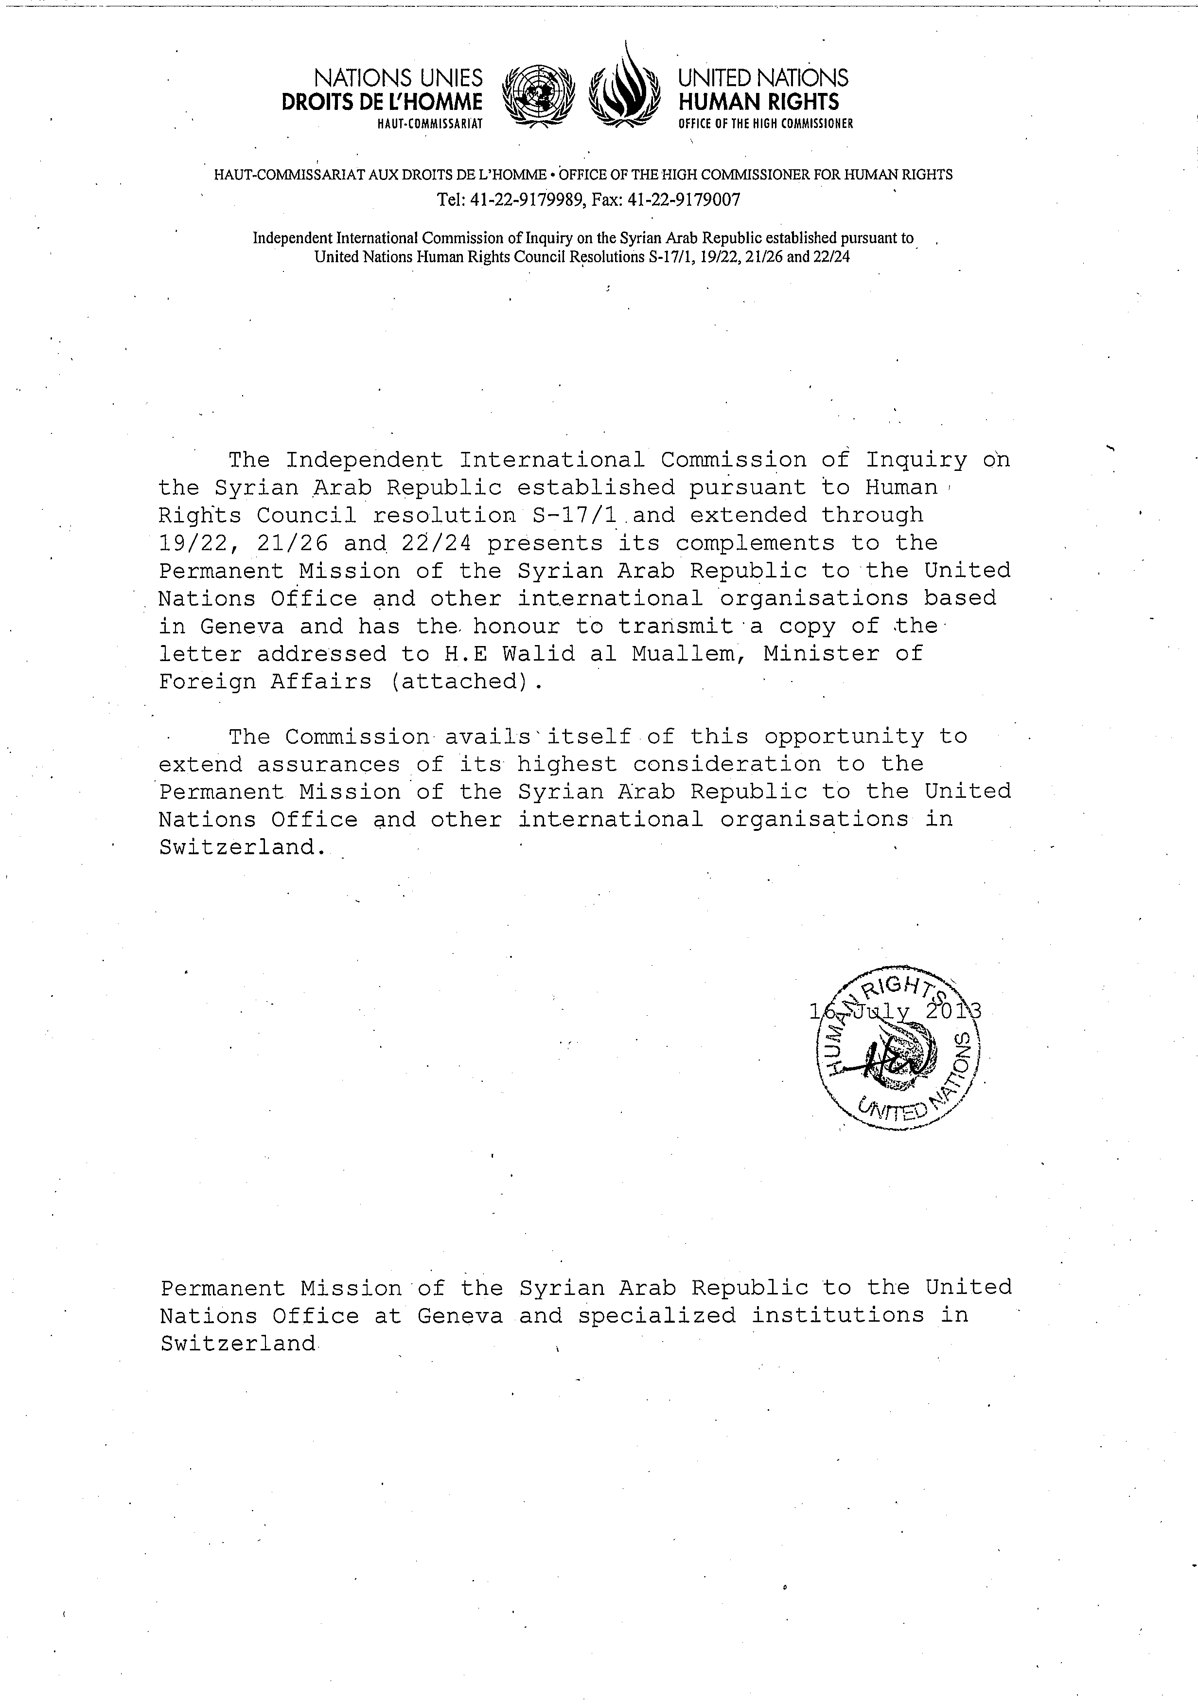
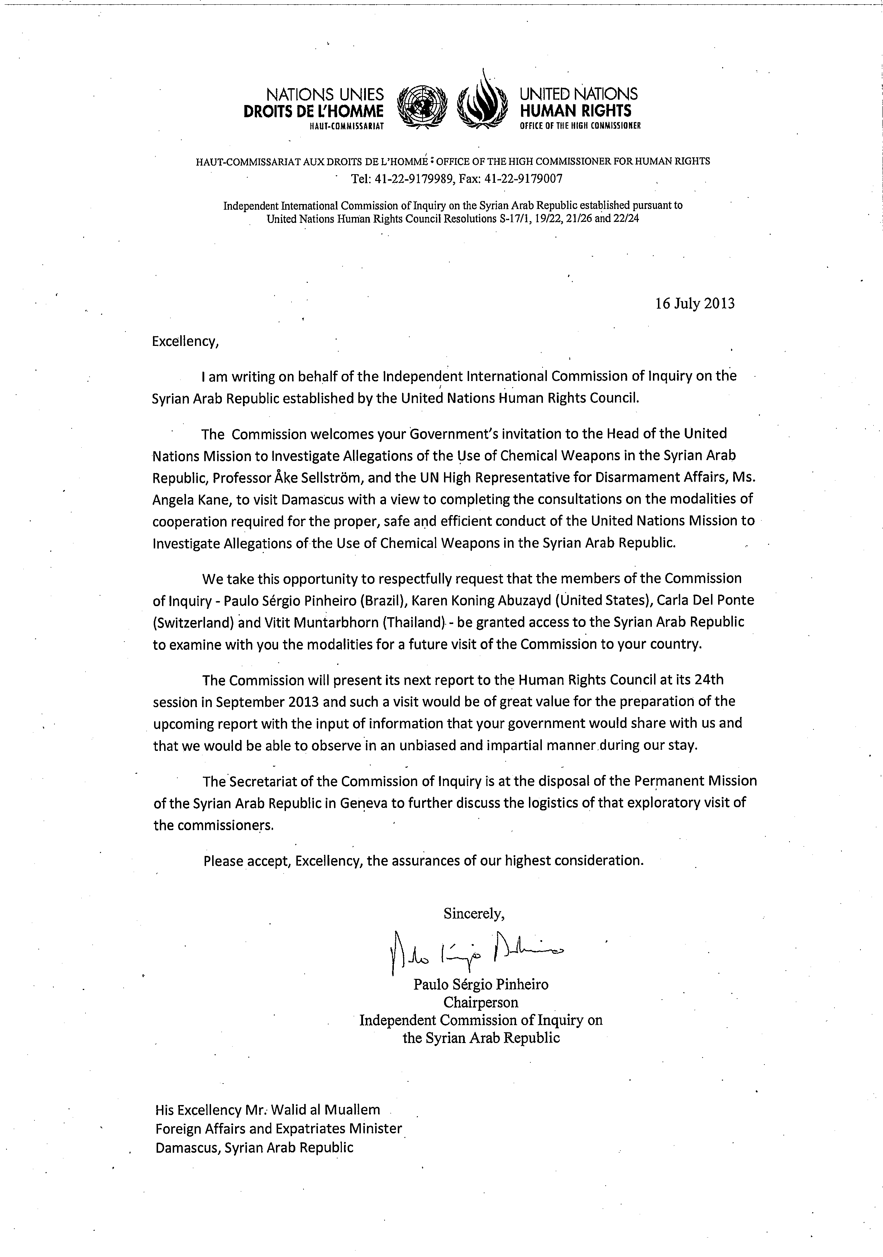
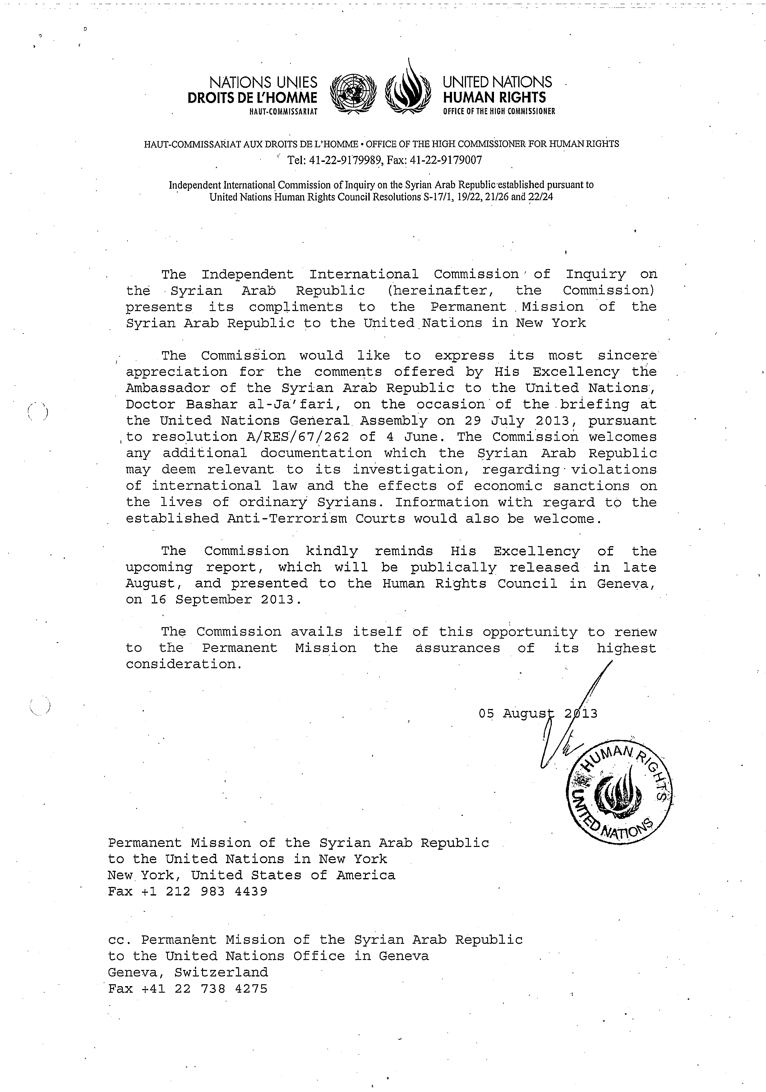
Annex II
[English only]
Massacres
1. The commission continued to carry out its specific mandate to investigate all massacres. In the incidents described, the intentional mass killing and identity of the perpetrator were confirmed to the commission’s evidentiary standards.
Government and pro-Government forces
Deir Baalbeh, Homs, 7-11 April 2012
2. In the Deir Baalbeh, near Homs city, between 20 and 40 men were killed in circumstances amounting to mass execution. Evidence indicated that the men, found in groups of two to 13, had been blindfolded and had their hands tied behind their backs, before being shot at close quarters. Reasonable grounds exist to believe that Government forces committed the massacre.
Al-Hamamiat, Hamah, 13 March 2013
3. Government forces stationed in Al-Hamamiat, a village located four kilometres east of Karnaz, Hamah, unlawfully executed six male farmers, residents of Al-Hamamiat. The men were internally displaced to Kafr Nabudah but had returned to Al-Hamamiat on 13 March. They approached troops stationed at a checkpoint, apparently seeking access to their farms. The commission has reasonable grounds to believe that Government forces stationed in Al-Hamamiat unlawfully killed the men in violation of international law.
Bab Amr, 27 March 2013
4. Government forces regained control over Bab Amr neighbourhood, Homs city, for 10 days during the second half of March. As per observed patterns, after heavy shelling, Government troops entered the neighbourhood as FSA fighters withdrew. Save for a number of elderly, most civilians had fled.
5. On 27 March, pro-Government forces, including the National Defence Forces, gathered several people, including seven elderly members of the Bzazi family. The seven were executed and their bodies burnt at the family house. The deceased were between the ages of 50 and 88 years old and included four women and three men. The Commission found reasonable grounds to believe that pro-Government forces unlawfully killed the Bzazi family members.
Khirbet Al-Teen, Homs, 10 April 2013
6. The Qadrou family, part of a community of Bedouins was executed in the area of Khirbet Al-Teen, in Homs countryside. The family included eight children (aged between two and 18 years old). Videos of the victims clearly show that they had been shot at close range and three of the child victim’s throats were slit. The village, along the Tartus-Homs highway, where the victims were found is surrounded by villages that support Government forces.
7. There are reasonable grounds to believe that pro-Government forces have unlawfully killed the Qadrou family.
Jdeidat Al-Fadel, western Damascus countryside, 21 April 2013
8. Accounts collected confirmed that thousands of internally displaced persons were in the area of Jdeidet Al-Fadel when Government forces launched a military operation on 15 April. With the participation of the 100th Regiment and 4th Brigade, all access points to the area were blocked by Government forces whereas heavy shelling from army bases west of the town targeted residential areas inside, causing a number of casualties. Some accounts state that the FSA had successfully overtaken a checkpoint outside Jdeidet Artouz which prompted the Government’s response. As fighting intensified, particularly between 15 and 21 April, thousands of civilians along with a number of anti-Government fighters were blocked inside the town. Hundreds of Government snipers were positioned on the town’s exit points. Snipers and soldiers positioned at the town exits killed many civilians trying to flee the hostilities. Anti-Government forces attempted to accompany thousands of civilians out of the area of combat but the blockade and the military operation made this impossible.
9. Collected evidence gave reasonable grounds to believe that Government forces executed a number of inhabitants once they took control of the town, including the Imam of the Mosque and his family.
Al-Bayda, Banias, Tartus, 2 May 2013
10. On the morning of 2 May, the army surrounded Al-Bayda and blocked the main exit points. Extensive shelling preceded the operation leading many civilians, especially those living at the edge of the village, to flee to surrounding agricultural areas. At approximately 7am Government forces entered with a force of 60-70 soldiers, establishing sniper positions around the main village square. Government forces proceeded to raid various streets in the village as members of the National Defence Forces joined the operation. Hundreds of civilians were arrested while some were executed in various locations. Evidence indicates that between 40-60 bodies were laid out in one room, a mobile phone shop, near the square. The bodies appear to have been burned. The victims appeared to have been first arrested and then executed in the square area. Some of the victims also appeared to have been hit in the head with blunt, heavy objects. Bodies of 30 women, also apparently executed, were found in a house not far from the centre while tens of bodies were strewn in the streets. Between150-250 civilians were allegedly killed. Testimonies were consistent that members of the National Defence Forces were actively involved in the raids and in many cases leading them.
11. Findings indicate that armed opposition was not present or actively engaged in hostilities in the village of Al-Bayda or its vicinity in the lead-up or during the alleged massacre. Some of the accounts suggest that Government forces were chasing a small activists’ cell in the village which it accused of facilitating the defection of regular soldiers from the army. It is evident, however, that the type of military operation and the alleged massacre that ensued were not in the context of an armed confrontation. Government forces with the support of the National Defence Forces operated freely throughout the day on 2 May in and around the village. There were no reported deceased pro-Government forces. The area where the village is located was under the full control of government forces. Accordingly, there are reasonable grounds to believe that government forces and affiliated militia including the National Defence Forces are the perpetrators of the Al-Bayda massacre
Ras Al-Nabe', Banias, Tartus, 3 May 2013
12. The incidents at Ras Al-Nabe' are closely connected to the events of Al-Bayda the preceding day. News spread that the National Defence Forces, with the support of the army, were moving towards the village as part of the same operation. Hundreds of civilians attempted to leave the village through the regular checkpoints but were pushed back. Some of the inhabitants managed to flee through dirt roads as main access roads to the village were blocked. Government forces proceeded to shell the village from various locations, including from a bridge connecting the village to other areas including Al-Bayda. Shelling lasted for approximately an hour before pro-Government forces moved in.
13. As they raided the village, civilians were captured and executed. The commission reviewed evidence of families that had been executed, including children, as part of the operation. Testimonies of those who witnessed the aftermath described bodies lying in the streets for days before the inhabitants could safely return to collect them. Some of the bodies appeared to have been hit with heavy or sharp objects, especially in the face and head area. According to reports the numbers killed is between150-200. As in Al-Bayda, there is no indication that the armed opposition was active in the village. The operation did not occur in the context of a military confrontation. Government forces were in full control of the area.
14. Based on an analysis of the evidence, there are reasonable grounds to believe that pro-Government forces perpetrated the 3 May killings in Ras Al-Nabe'.
Khirbat Al-Souda, Homs, 15 May 2013
15. On 15 May, anti-Government armed groups attacked a checkpoint at the railway linking Homs and Tartus. In retaliation for this incident, Government forces from the checkpoint shelled and raided Khirbat Al-Souda, a small village five kilometres north of Homs city, killing 16 people, including two women and a three-year-old child, and burned their bodies.
16. In eight incidents detailed above, reasonable grounds exist to believe that the war crime of murder was committed by Government and pro-Government forces, including the National Defence Forces.
Anti-Government armed groups
Hatla, Dayr Az-Zawr, 11 June 2013
17. On June 11 at approximately 5:45 am, several anti-Government armed groups, including members of Jabhat Al-Nusra, attacked the Shi'ite areas of Hatla, a mixed, but Sunni-majority, village located in eastern Dayr Az-Zawr. In the ensuing fight, anti-Government armed groups defeated the outnumbered and outgunned Shi’ite fighters. More than 20 were killed and some were captured. Ten anti-Government fighters were killed during the attack.
18. During the takeover, anti-Government armed group fighters conducted home invasions, killing and summarily executing (by shooting at close range) many Shia including at least 30 civilians, among them children, women and elderly. Fighters also set civilian houses and a Shia mosque on fire as they shouted sectarian slogans.
19. There are reasonable grounds to believe that the anti-Government fighters who attacked Hatla unlawfully killed at least 20 civilians in violation of international law. In relation to the 11 June killings in Hatla, anti-Government armed groups involved have committed the war crime of murder.
Incidents remaining under investigation
20. In some incidents that remain under investigation, the fact of the illegal killing was confirmed; however the perpetrator could not be identified. In other cases the circumstances of the killing is not sufficiently clear to make a determination as to its legality.
Abel village, Homs, 25 March 2013
Al-Burj, Talkalakh, Homs, 30 March 2013
Jib Khasara, Hamah, 22 May 2013
Saroaf Checkpoint, Nawa, Dara’a, 1 June 2013
Mazra, Aleppo, 24 June 2013
Al-Haswiyah, Homs, 14 July 2013
Incidents to be investigated during next reporting period as of 31 July 2013
Al-Bayda, Tartus, 21 July 2013
Khan Al-Assal, Aleppo, 22 July 2013
Til Aran, Aleppo 31 July 2013
Annex III
[English only]
Inquiry into events in Al Qusayr
1. Pro-Government forces, including Hezbollah, launched a major offensive against the region of Al-Qusayr, Homs governorate, from 4 April to 8 June 2013, forcing the withdrawal of anti-Government armed groups from the town and the surrounding countryside.
2. In its Resolution A/HRC/23/1, the Human Rights Council requested the Commission of Inquiry to “urgently conduct a comprehensive, independent and unfettered inquiry into the events in Al Qusayr” and requested the findings of the inquiry be included in its report to the Council at its 24th session.
3. This Annex details the offensive according to information collected during the investigations, taken together with documentary material such as photographs, satellite imagery and video recordings.
Background
4. Al-Qusayr is located in Homs province at a strategic juncture for the warring parties’ forces operating in the central governorates. The town is located close to the Lebanese borders along the main line of communication between Damascus and both northern and coastal governorates.
5. Since early 2012, anti-Government armed groups have controlled parts of the locality and extended their presence to its countryside, reducing the presence of Government forces to the eastern neighbourhood of Al-Qusayr city around the security square. Control of the town enabled the armed groups to ensure cross-border movement of arms and logistics while also disrupting the Government’s supply lines from Lebanon’s Bekaa Valley.
6. Government forces responded by imposing a siege on Al-Qusayr towns and surrounding villages. The Syrian army prevented the flow of food and water into the areas from the northern and eastern access points, while Hezbollah did the same following the assumption of control of access points to the south and west. For over a year, Al-Qusayr and nearby villages came under heavy shelling and aerial bombardment by Government forces. Both the Government siege and shelling of the area intensified in the weeks prior to the ground attacks.
7. From April to mid-June, anti-Government armed groups fired homemade rockets and artillery shells into villages, such as Hermel, under Government and Hezbollah control. Some rockets fell on Al-Qasr, a village inside Lebanon, causing civilian casualties.
8. In the Al-Qusayr western countryside, tensions increased between anti-Government armed groups and pro-Government armed elements in the Shia villages. This led to Hezbollah’s incremental involvement. As a result of clashes between the warring parties, local inhabitants from the predominantly Sunni villages around Al-Qusayr were internally displaced to safer areas in Al-Qalamoun, northeastern Damascus countryside, with thousands fleeing to the town of Ersal in Lebanon.
9. Inside the town of Al-Qusayr, various anti-Government armed groups collaborated during operations under the supervision of Al-Qusayr Military Council. The main groups included Al-Farouq Battalions, Al-Waleed Battalions, Fajr Al-Islam Brigade, Bashair Al-Nasr Battalions, Al-Haq Brigade and a group of Jabhat Al-Nusra fighters. Immediately prior to the Government offensive, there were approximately 2,000 – 2,500 anti-Government armed group fighters inside Al-Qusayr.
10. In March 2013, the siege around Al-Qusayr town and the surrounding countryside tightened. Villages west of the Al-Assi River, predominantly populated by Sunni Muslims, were particularly affected. These included Al-Burhaniya, Al- Radwaniyeh, Saqraja, Ayn Al-Tannur, Arjoun and Al-Hamidiyah.
11. In the weeks prior to the May 2013 offensive, there were severe shortages of food, water and medicine inside the town of Al-Qusayr. By early May, Hezbollah had taken control of the Ain Tanour and Hamah water stations, four kilometres west and two kilometres north of Al-Qusayr town respectively. Water to the town, already limited, was cut entirely. Sanitation levels declined rapidly, resulting in a corresponding increase in infectious diseases. As medical supplies ran low, the ability of hospitals and clinics to treat civilians injured by shelling and by crossfire was severely compromised. Pro-Government forces refused to allow Red Crescent ambulances to enter Al-Qusayr to evacuate the wounded.
Preparatory operations and bombardment
12. In reaction to the coordinated attack by anti-Government armed groups on southern districts of Homs city in March 2013, a Government offensive on Al-Qusayr was initiated in early April. This offensive formed a key part of the Government’s strategy to secure Homs governorate.
13. Government forces, supported by foreign combatants including thousands of Hezbollah fighters, captured the majority of villages in the countryside in order to cut the armed groups’ supply lines and prevent their withdrawal. From 11 April to 13 May, Hezbollah fighters controlled the Sunni villages located in the southwest of Al-Qusayr (west of Al-Assi River), while the Government regained territory in Homs city and challenged the armed groups’ positions from the northeast. These tactics ultimately blockaded the armed groups in a triangle formed by the towns of Al-Qusayr, Buwaydah Al-Sharqiyah and Arjoun. The tight siege imposed on the town of Al-Qusayr prevented the transfer of reinforcements and weapons to the armed groups.
14. Shelling and airstrikes on Al-Qusayr town and surrounding villages also escalated in the weeks prior to the ground attacks. The villages to the southwest of Al-Qusayr were shelled with mortars and came under aerial bombardment from jet fighters and helicopters. Al-Qusayr also came under sustained attack, from shelling, surface-to-surface missiles and aerial bombardment. In the ten days prior to the ground attacks, shelling and bombardments on the area were near continuous.
Attack on Al-Qusayr city
15. On 19 May, Hezbollah fighters along with Government troops and National Defence Forces launched a final attack on Al-Qusayr from several directions, reportedly forcing a negotiated withdrawal of anti-Government fighters. Witnesses stated that the armed groups withdrew in exchange for the lifting of the siege and the evacuation of civilians and injured persons.
16. The ground attack by the pro-Government forces was accompanied by an extensive campaign of shelling and bombardment involving the use of artillery and airpower. Corroborated interviews indicated the use by Hezbollah fighters of a highly explosive shoulder fired missile, likely to have been thermobaric in nature. This weaponry caused a significant number of casualties among anti-Government fighters and civilians, as well as extensive destruction of buildings.
17. Within 24 hours, on 20 May, Government forces and Hezbollah fighters managed to take control of Al-Qusayr town, with the exception of its northern neighbourhood where anti-Government armed groups redeployed. Fighting continued throughout May, with both sides reinforcing their positions in and around the town. Further Government reinforcements were redeployed from Damascus and Dara’a, including from the Syrian Republican Guard.
18. Approximately 300 anti-Government fighters, including elements from the Al-Tawheed Brigade from Aleppo and the Al-Usra Army from Dayr Al-Zawr, arrived to support the armed groups inside Al-Qusayr. Despite those reinforcements, anti-Government armed groups began to lose ground to Government forces and Hezbollah. Government forces benefitted not only of their superior weaponry and their ability to sever the armed groups’ supply lines into Al-Qusayr but also from Hezbollah’s expertise in street-to-street insurgency fighting. Approximately 500 armed group fighters were killed by shelling and by gunfire during the ground operations. An estimated 800 to 1000 fighters were injured, rendering them hors de combat. The Government later indicated that approximately 1,000 anti-Government fighters were captured. It has not been able to confirm these numbers. The whereabouts and treatment of many captured fighters is currently unknown.
19. The remaining fighters were unable to hold ground in the face of the pro-Government onslaught. Squeezed between northern Al-Qusayr and Buwaydah Al-Sharqiyah, the fighters, together with civilians and hors de combat fighters, were forced – or allowed – to withdraw from Al-Qusayr on 5 June along a narrow corridor still under opposition control to reach the villages of Dabaa, Salhiyah and Buwaydah Al-Sharqiyah.
20. Until the last day of the offensive, scores of women, children and elderly had been able to exit Al-Qusayr through military checkpoints in Domaynah Al-Sharkiyah and Shamseen. However, those at risk of arbitrary arrest and unlawful detention – themselves a gateway to a range of other violations – had little choice but to remain inside the town. This included civilian men, boys over 12 years old and women related to wanted persons, such as defectors. They formed part of the convoy leaving Al-Qusayr in the last days of the battle.
The fall of Al-Qusayr
21. It has been difficult to estimates the size of the convoy that exited Al-Qusayr on 5 June, primarily because of the sheer number of people moving in a narrow formation out of Al-Qusayr towards Buwaydah Al-Sharqiyah. However, there are reasonable grounds to believe that the total number was between 13,000 and 15,000 people. Corroborated accounts indicate that at least 10,000 civilians, mostly males over 12 years and over, were part of this convoy. This large group moved along dirt roads to avoid army positions.
22. From 6 to 8 June, the convoy of internally displaced moved towards the Homs-Damascus Highway through Domaynah Al-Sharkiyah, Hamra and Al-Hussayniyah. The few persons remaining in these villages joined the convoy.
23. After taking control of the town of Al-Qusayr, pro-Government forces successively recaptured the remaining villages including Dabaa (6 June) and Buwaydah Al-Sharqiyah (8 June). The displacement of thousands of civilians and fighters, including hundreds of injured, followed.
24. At dawn on 7 June, the first group of civilians and fighters, numbering approximately 500 people, arrived at the Homs-Damascus highway. The majority of the group was able to cross, in spite of shelling from nearby army checkpoints, which caused a number of casualties. Continued shelling and the resulting deaths led the remaining thousands still waiting to cross to retreat a few kilometres to a farming area next to Al-Hussayniyah where they stayed until the following night.
25. At around 9pm on 8 June, the group of displaced tried once again to cross the highway but were targeted by shelling from army positions in nearby Shamseen and Shinshar. In an effort to facilitate the crossing of the highway by waiting civilians, anti-Government fighters reportedly attacked the Shamseen checkpoint. By dawn, more groups of civilians and injured fighters were still unable to reach east of the highway. They returned to the area of the farms, where they spent two more days suffering from lack of water, food and medication. In one instance on 8 June, army tanks and troops from checkpoints in the area attacked the civilians and fighters hiding in the farms, but they were pushed back by anti-Government fighters.
26. On or around 8 June, following a negotiation, armed groups returned the bodies of two Hezbollah fighters in exchange for the safe passage of 34 seriously injured armed group fighters to the Lebanese Red Crescent. The injured fighters suffered beatings while under Hezbollah’s control but were taken alive to the border and handed over to the Red Crescent for medical treatment.
27. It was not until on or about 11 June that the groups of fighters and civilians were able to cross the highway and entered the localities of Shamseen, Hissiyah and Al-Dibah. They settled there for a few days before leaving to other areas across the country and towards Ersal in Lebanon.
Casualties
28. The commission has, to date, been able to verify the killing of 450 people during the offensive on Al-Qusayr town. Approximately half were civilian casualties, killed primarily in the shelling and aerial bombardment of the town in the early days of the offensive.
29. While civilians were killed by gunfire, it has not been possible to determine who fired the shots or the circumstances under which the shooting took place. These civilians may have been killed in crossfire during the intense street-to-street battles.
Findings
Unlawful attacks
Pro-Government forces
30. In its shelling and aerial bombardment of both Al-Qusayr and the Al-Qusayr region in the months and weeks preceding the military offensive – and in particular during the intense shelling which occurred in the ten days prior to the ground attack – Government forces conducted themselves in flagrant disregard of the distinction between civilians and persons directly participating in hostilities.
31. On 17 April, the aerial bombardment of Buwaydah Al-Sharqiyah killed at least 12 people, including two women and two children. On June 7, at least a dozen civilians displaced from Al-Qusayr were killed when the army shelled orchards on the outskirts of the town. Between 5 and 12 June, Government shelling targeted internally displaced persons fleeing Al-Qusayr, the vast majority of whom were civilians and hors de combat fighters. Civilians were killed in the shelling as they attempted to cross the Damascus-Homs highway in search of a safe haven.
32. During the attack on Al-Qusayr and the villages around it, the Government deployed extensive aerial and artillery capabilities. This included imprecise weaponry such as surface-to-surface missiles which destroyed not only individual targets but also blocks of buildings. That the majority of civilians were killed in the shelling and aerial bombardment underlines the failure to take adequate precautions to protect civilians.
33. As set out in the chapter on Unlawful Attacks, Government forces consistently transgressed the fundamental principle of the laws of war that they must at all times distinguish between civilian and military objectives.
34. Government forces and Hezbollah also positioned military objectives inside the villages to the south-west of Al-Qusayr, endangering the civilian population and violating international legal obligations.
Anti-Government armed groups
35. Anti-Government armed groups shelled villages west of Al-Qusayr, home predominantly to a Shia community, without taking precautions to protect civilians living inside. On 27 May, a Lebanese girl aged 17 was killed in a rebel mortar attack on the Hezbollah stronghold of Hermel. On 11 June, one man was killed and several people were injured during a rocket attack also on Hermel.
36. Anti-Government armed groups used mortars, rockets and snipers in a manner that failed to distinguish civilian and military objectives, thereby committing unlawful attacks.
37. Armed groups also operated within civilian areas, including in the town of Al-Qusayr itself, violating international legal obligations to avoid positioning military objectives within or near densely populated areas.
Imposition of sieges
Pro-Government forces
38. Government forces and Hezbollah had imposed a siege on the Al-Qusayr area since late 2012. In the weeks prior to the military offensive, the siege tightened considerably with harrowing consequences for the civilians remaining inside Al-Qusayr town and the surrounding villages. The cutting off of medical supplies into Al-Qusayr town, in particular, had dire consequences for the ability of the hospitals and clinics to treat those injured by shelling and gunfire.
39. As detailed in the section on Sieges and Attacks on Food Security, pro-Government forces have a legal obligation to allow and facilitate the unimpeded passage of humanitarian relief. The use of starvation as a method of warfare is clearly prohibited under the laws of war. There is strong evidence to suggest the siege was imposed for the specific reason to render the conditions of life unbearable, weakening the armed groups and forcing civilians, who were so able, to flee.
40. Government forces and Hezbollah have imposed sieges and blockades in the Al-Qusayr region, without complying with their obligations under international humanitarian law.
Torture and other forms of ill-treatment
Pro-Government forces
41. Following a negotiated exchange of 34 seriously injured armed group fighters for the bodies of two Hezbollah fighters on or around 8 June, the injured hors de combat fighters were beaten by Hezbollah members prior to their transfer to the Lebanese Red Crescent for medical treatment. Such conduct is in flagrant disregard for the protections accorded to the sick, wounded and hors de combat fighters from ill-treatment.
Massacres and other unlawful killings
42. Civilians were killed in the indiscriminate shelling of Al-Qusayr and its surroundings. It has not been possible to determine, beyond the requisite standard of proof, the circumstances in which those killed by gunfire died. Given the fierce fighting that took place in Al-Qusayr, there is a strong possibility that those killed may have been caught in crossfire between the warring factions. There is no evidence, as yet, to indicate that fighters on either side were killed in circumstances that would have deemed those killings unlawful. Investigations are continuing.

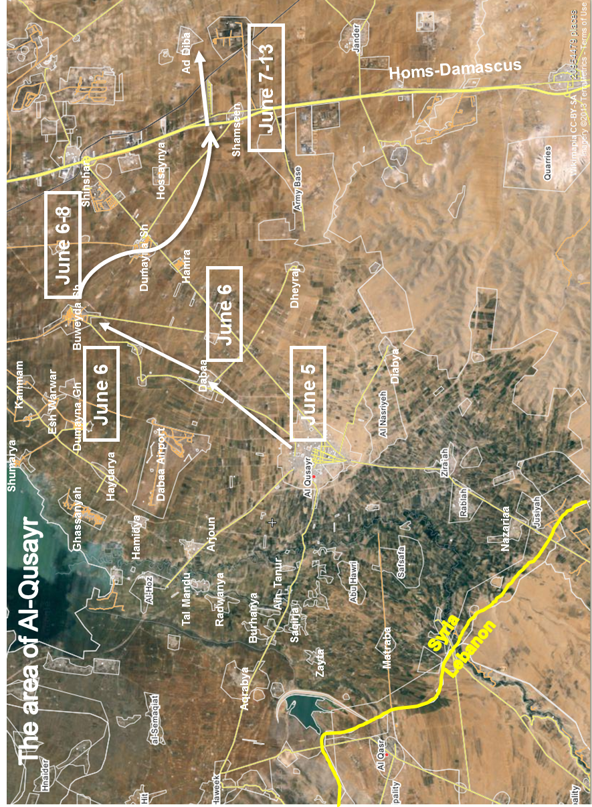
Annex IV
[English only]
Photographs of Al-Nayrab (Aleppo), May and July 2013
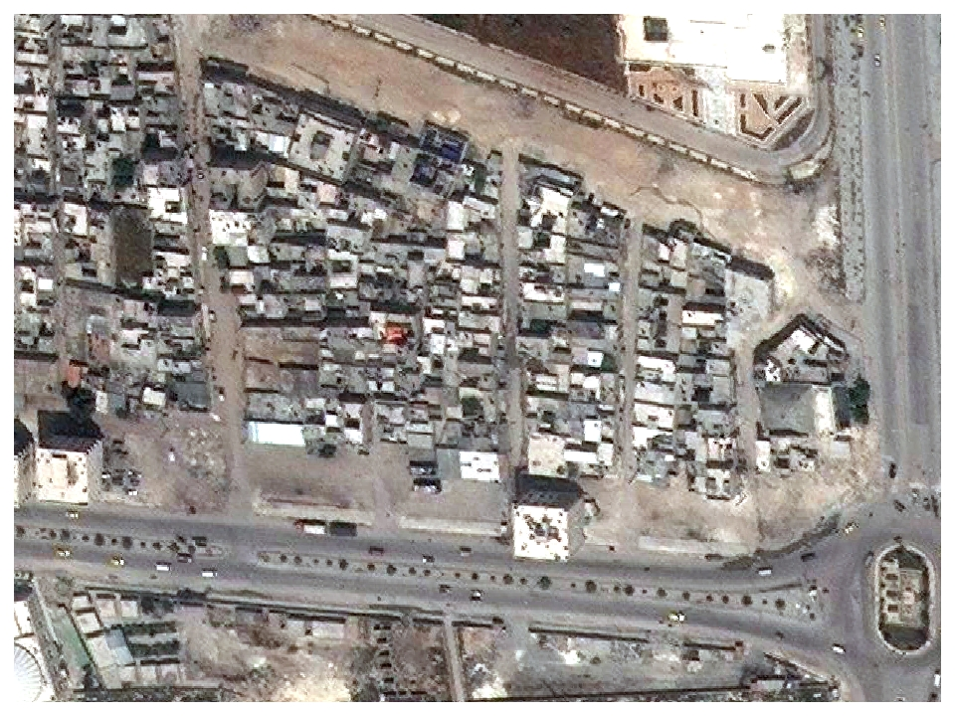
Digital Globe World View 1 – 13 May
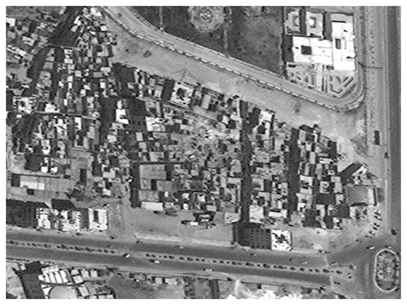 Digital Globe World View 1 – 27 July
Annex V
[English only]
Map of the Syrian Arab Republic
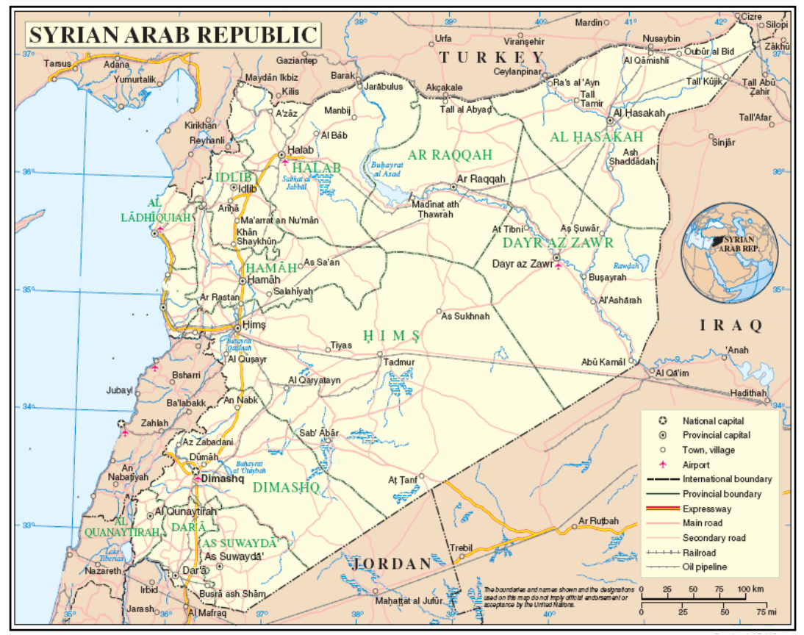

* The annexes to the present report are circulated as received, in the language of submission only.
The commissioners are Paulo Sérgio Pinheiro (Chairperson), Karen Koning AbuZayd, Vitit Muntarbhorn and Carla Del Ponte.
S-17/2/Add.1, A/HRC/19/69, A/HRC/21/50, A/HRC/22/59 and A/HRC/23/58.
A/HRC/23/58, para. 22.
In May 2013, the European Union voted to lift sanctions to allow other opposition groups to sell the oil they control.
See also annex II.
See A/HRC/23/58, para. 83.
The photographs contained in annex IV show the impact site of a missile strike in Al-Nayrab, southern Aleppo city, which destroyed approximately 12 buildings.
Human Rights Council resolution 21/26, para. 10.
A/66/865-S/2012/522.
See A/HRC/22/59, para 42.

