From the Institutions of Higher Education
KOSOVO

To: UNESCO DG Office
EU Commission for Research, Science and Innovation
UNESCO National Delegations

09.10.15, Prishtina
Kosovo

Honorable Director General of UNESCO, Madame Bokova,
Honorable EU Commissioner for Research, Science and Innovation, Mr. Moedas,
Honorable Ambassadors,

We, the undersigned, write this letter to call your attention to the issue of Kosovo’s application for UNESCO membership. We are not writing regarding the politics of the application, but, instead, to draw your attention to two situations that we have experienced in the last year, which you may find relevant for the debate on the merits of Kosovo’s application.

First, let us mention the case of Qendrim Gashi, a professor of mathematics in the University of Prishtina. Professor Gashi received his University diploma in 2002 at the age of 18. He got his M.A. in Mathematics at the University of Cambridge at the age of 19 and his Ph.D. at the University of Chicago at the age of 24. He lectured at the University of Chicago at the age of 21. As a Fellow of the European Post-Doctoral Institute, he lectured at the Institut des Hautes Études Scientifiques (Bures-sur-Yvette, France), the Isaac Newton Institute for Mathematical Sciences (Cambridge, UK) and the Max-Planck-Institut für Mathematik (Bonn, Germany).

Professor Gashi then decided to live in Kosovo and help in the nation-building efforts, though he would have been much better paid and likely more challenged academically had he decided to live abroad. We are grateful for him and hundreds of others like him, as well as the tens of thousands of students in our universities, who are helping Kosovo develop the tools and skills required to overcome the challenges of political and economic transition, building an open society with developed economy. We are the youngest nation in Europe in terms of demographics, and education is a key component for our progress.

Professor Gashi recently worked on a project, together with colleagues from Spain and Austria, to organize a two-week research school at the doctoral and post-doctoral level in Kosovo in 2017. The project would, for the first time, bring top world mathematicians to the country, opening the minds of students in Kosovo.

The team was advised by peers around the world to seek support from CIMPA (Centre International de Mathématiques Pures et Appliquées), the UNESCO center based in Nice. Despite persistent outreach, this team of mathematicians was told they could not receive support in any form, as Kosovo is not yet a member of UNESCO, and CIMPA’s hands were tied. This was the final decision, expressed with regret, by CIMPA leadership.

The second case concerns the challenges that Kosovo faced recently in obtaining financial assistance from an aid institution. Last year, Kosovo applied for grants for implementing reforms in education and the fight against corruption from The Millennium Challenge Corporation (MCC), the United States foreign aid agency. A country is considered eligible for a compact (aid grant) from the MCC if it scores well on 17 indicators. No political considerations are given. Two of the indicators are dependent on UNESCO official statistics. As Kosovo is not a member of UNESCO, it does not have any separate statistics vetted by UNESCO and has been hampered in applying for funds in this and other institutions that are completely separate from UNESCO, yet rely on UNESCO data for decision-making.

These two recent cases highlight how Kosovo is barred from dozens, if not hundreds, of programs, funds, fellowships, exchanges, and other opportunities for academic development due to the lack of membership to UNESCO.

We are on the verge of signing the Stabilization and Association Agreement with the EU, which will hopefully unlock Kosovo’s access to EU science and innovation programs. Still, lack of membership to UNESCO will continue to be detrimental to our development.

Therefore, we, the rectors of 4 public universities and 22 private university colleges in the Republic of Kosovo, are asking for your kind support for our membership bid to UNESCO. We do not wish to debate Kosovo’s status or the past war. We simply want to ensure that our children, the future of the Republic of Kosovo, have the very same opportunities as the children of the 195 member states of UNESCO. Isolating our country will deliver a fatal blow to the aggressive pursuit of academic and scientific curiosity, as well as the advancement of our cultural heritage.

Many thanks for your attention to this critical matter.

Yours sincerely,

On behalf of the Public and Private Higher Education Institutions of the Republic of Kosovo:
[signatures of Rectors of 26 institutions of higher education in Republic of Kosovo]

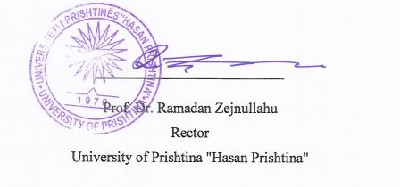 | 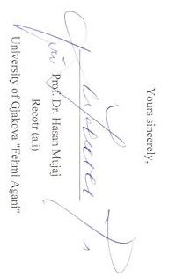
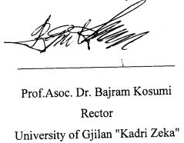 | 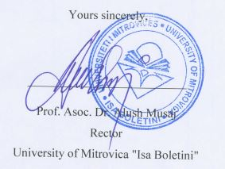
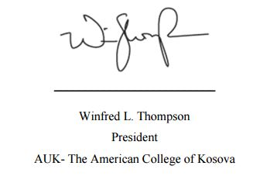 | 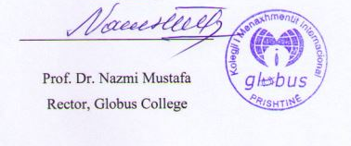
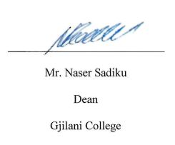 | 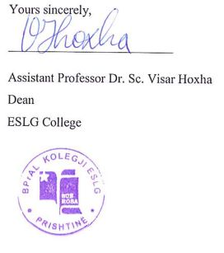
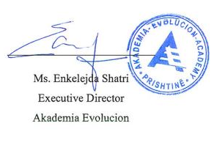 | 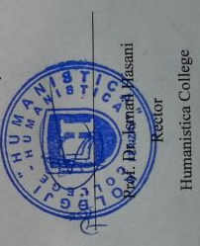
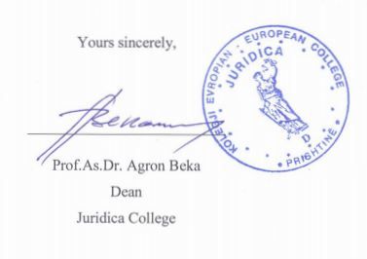 | 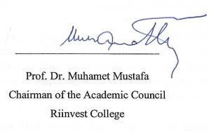
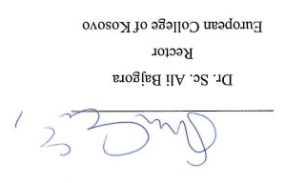 | 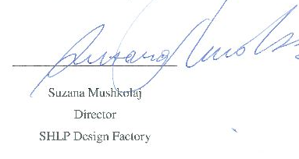
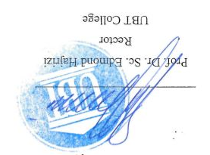 | 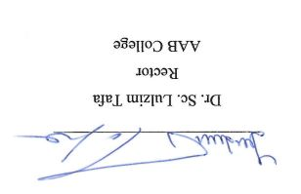
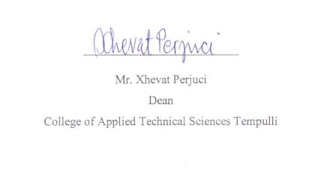 | 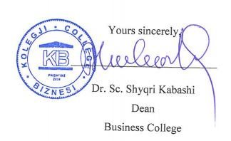
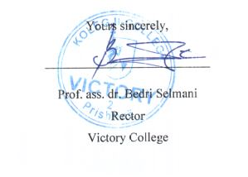 | 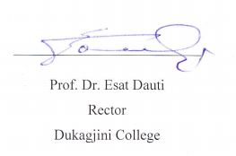
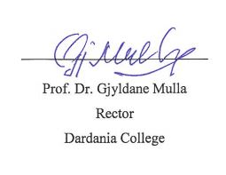 | 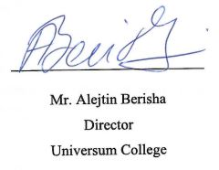
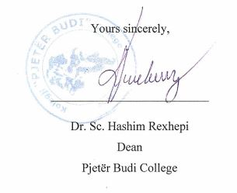 | 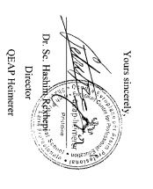
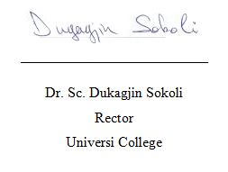 | 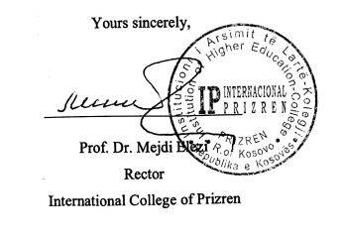
11

3

