

**Republika e Kosovës**

**Republika Kosova - Republic of Kosovo**

*Qeveria - Vlada - Government*

***Ministria e Financave***

***Ministarstvo za Finansije – Ministry of Finance***

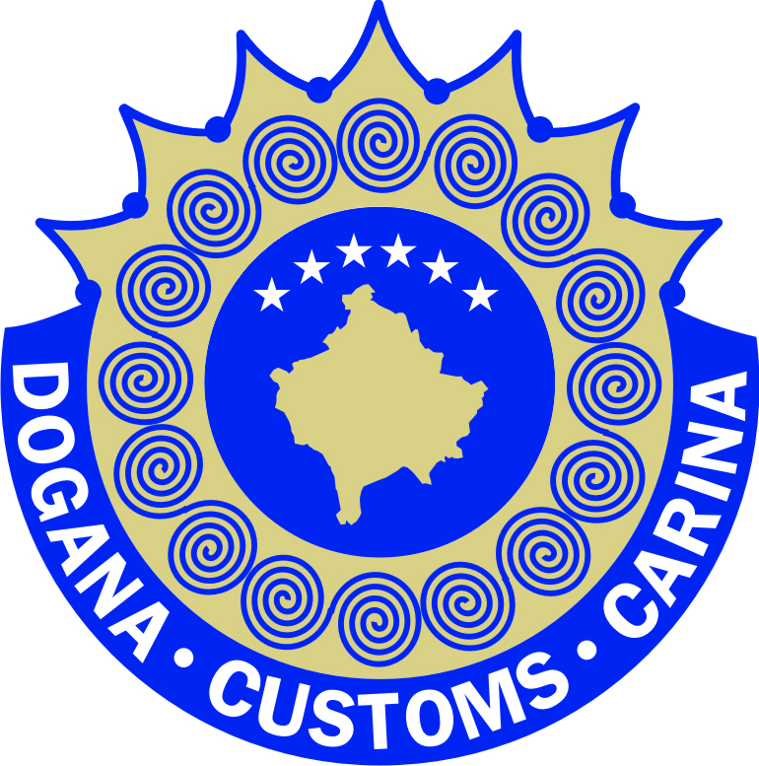

***Dogana e Kosovës – Carina Kosova – Kosovo Customs***

***Zyra e drejtorit të përgjithshëm***

Dear all,

Allow me to let you know through this notification on the continuation of issue of donations treatment, Kosovo Customs in conformity with the legislation in force and based on the implementation of protective measures according to the decision of the Government of the Republic of Kosovo on imported products originating from Serbia and Bosnia, has implemented these decisions and at the same time has treated and approved all donations directed to her.

Kosovo Customs in compliance with the applicable legislation has handled and approved all requests for release of donations to northern municipalities and governmental institutions. Goods that were part of these donations were to help humanitarian programs and projects as well as reconstruction projects in Kosovo.

On the category of donations, namely the nature of humanitarian goods are the following goods including: flour, maize, food products, hygienic and sanitary goods, medicines and medical equipment, petroleum and petroleum products for heating schools, hospitals and churches and also including pellet for heating, etc.

Kosovo Customs during the period after the entry into force of the safeguard measures has dealt with and approved donations as requested by the four northern municipalities and the Serbian Orthodox Church as follow:

* On 07.11.2018 for the North Mitrovica Municipality were approved donations (young plant) in the amount of **46,771.00€**
* On 09.11.2018, the donation (food and meat products) for the Student Centre in North Mitrovica was approved in the amount of **10,871.00 €**
* On 19.11.18 donations (food and fish products) for the Student Centre in North Mitrovica were approved in the amount of **3,775.83€**
* On 22.11.2018 was approved the donation (oil and heating mazut) in the amount of **75,000.00 €** (donation has to arrive)
* On 22.11.2018 the donation (medicines and medical equipment) was approved in the amount of **242,356.38€** (donation has to arrive)
* On 29.11.18 the donation (food and meat products) for the Student Center in North Mitrovica was approved in the amount of **2,188.72 €**
* On 30.11.2018 donations (pellets) for the Orthodox Church were approved in the amount of **3,501.44 €**
* On 30.11.2018 the donation (25 tons flour type 500) was approved for the Orthodox Church in the amount of **7,000.00 €**
* On 20.11.2018, a donation (25 tonnes) was approved for the Orthodox Church in the amount of **3,775.83 €**
* On 06.11.2018 was approved donation (25 tons of oil) for the Orthodox Church in the amount of **16,196.00 Euro**
* On 01.12.2018 donations (different foods, oil, rice, rice, flour, etc.) were approved for the Serb community according to UNHCR donation in amount of **8, 940.00 Euro**
* Three donations from Foundation Kosovo Luxemburg (manufacturing machinery) for the Serbian community were approved on 06.11-13.11.2018 according to the donation in amount of **4, 299.00 Euro**
* On date 16.11-26.11.2013 3 donations from IOM (manufacturing machinery, computers) for the Serbian community were approved according to the donation in the amount of **16.515.00 Euro.**

Also, the exemptions for the private baggage of passengers has been treated based on the Customs and Excise Code (Code No. 03 / L-109), which implies the exemptions brought to Kosovo by personal luggage in the value of goods up to 175 €, which carry passengers and which is allowed without tax.

For the 10 day period there were over 50 different cases (mainly groceries) with personal luggage which were exempted from the obligations as per bellow report;

- BCP Jarinje - about 20 cases

- BCP Dheu i Bardhë - 25 cases

- BCP Merdare - 10 cases

With respect,

Kosovo Customs